
FATIMA JINNAH WOMEN UNIVERSITY
RAWALPINDI
Department Of Software Engineering

Cloud Computing Lab
Saira Ejaz [2023-BSE-057]
Section: 5-B
LAB NO 14
Task 0 – Lab Setup (Codespace & GH CLI)
- task0_codespace_open.png
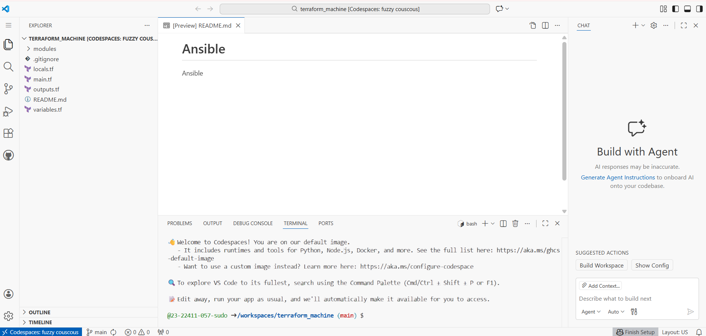
- task0_env_check.png
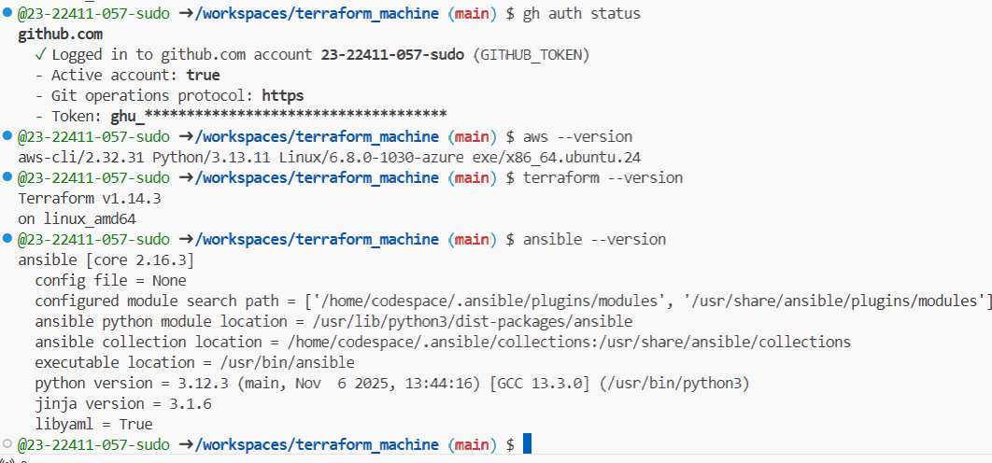
- task0_aws_config.png
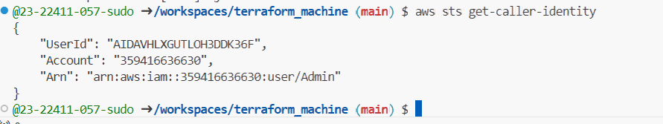
Task 1 – Generate ssh key and Initial Terraform apply
- Check SSH directory & generate SSH key pair if not already present:
task1_ssh_keygen_before.png — ls ~/.ssh before key generation.
task1_ssh_keygen.png — output of ssh-keygen command.
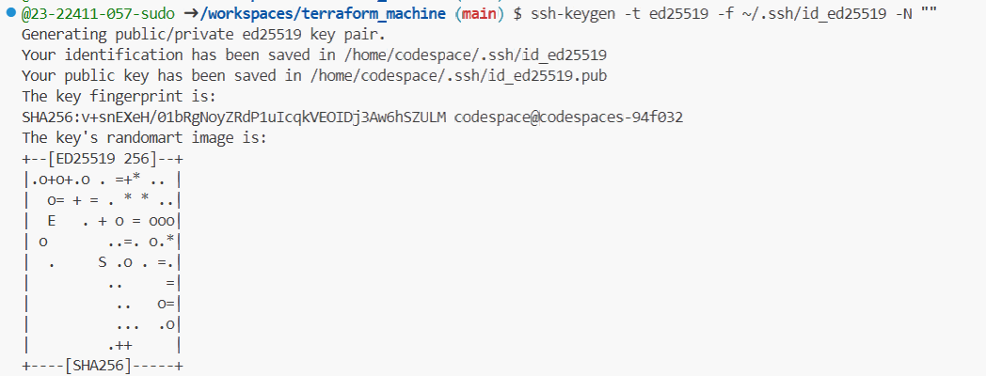
task1_ssh_keygen_after.png — ls -la ~/.ssh showing id_ed25519 and id_ed25519.pub.
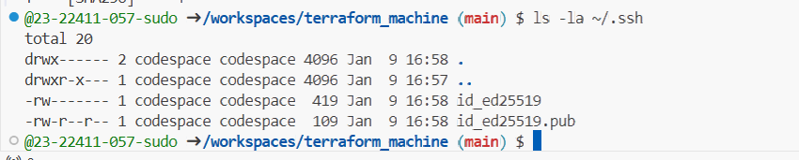
- Create terraform.tfvars in the repo root:
task1_terraform_tfvars_created.png — touch terraform.tfvars and ls -la terraform.tfvars.
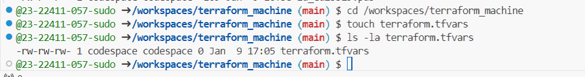
task1_terraform_tfvars.png — content of terraform.tfvars.
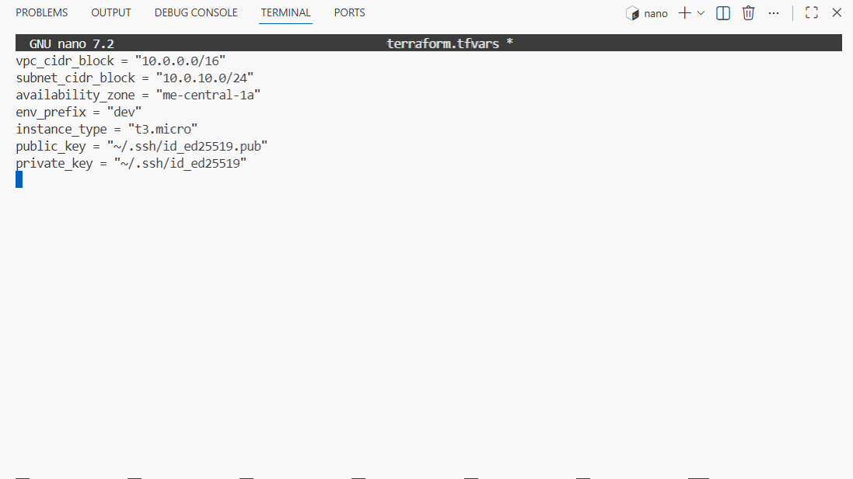
- Initialize Terraform:
task1_terraform_init.png — terraform init output.
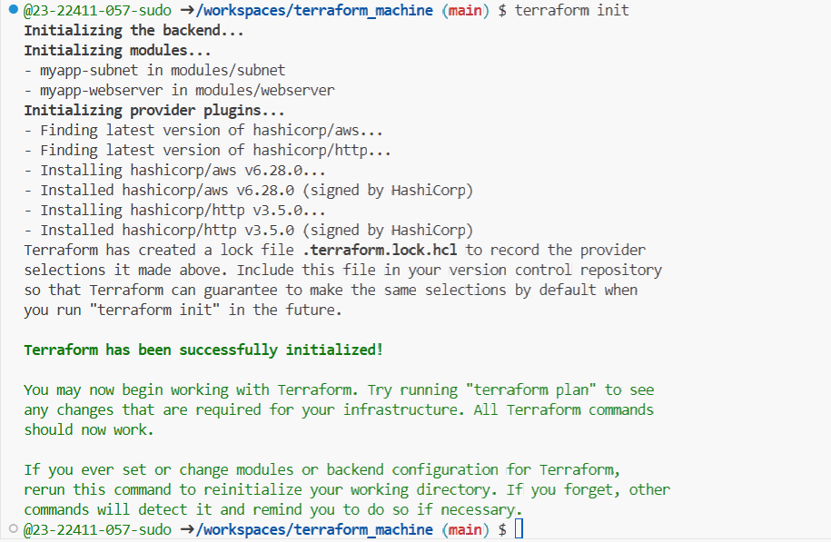
- Apply Terraform to create 2 EC2 instances (as defined in the existing Terraform code):
Task1_terraform_apply_2_instances.png — terraform apply output showing 2 instances created.
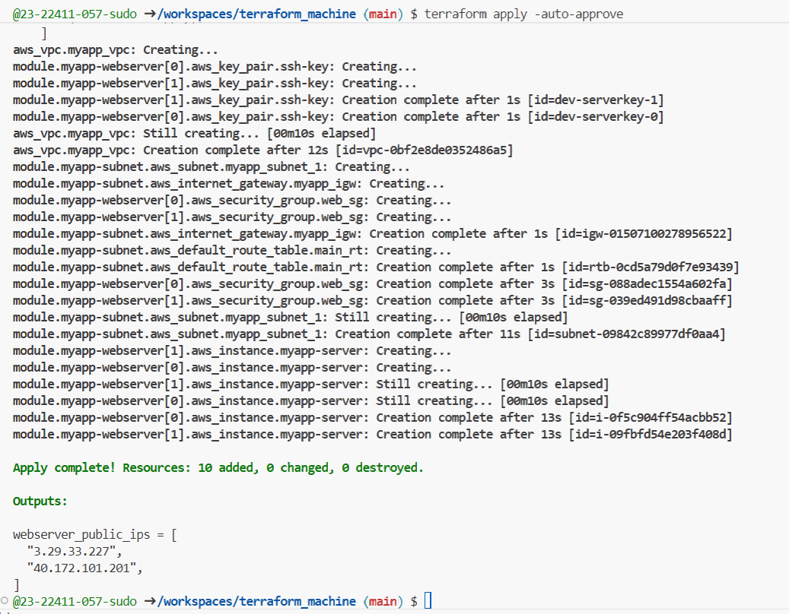
- Check outputs
task1_terraform_output_ips.png — terraform output showing instance IPs.
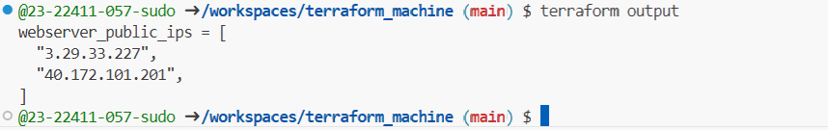
Task 2 – Static Ansible inventory with two EC2 instances
- Install Ansible (core) using pipx:
task2_ansible_install.png — pipx install ansible-core and ansible --version output.
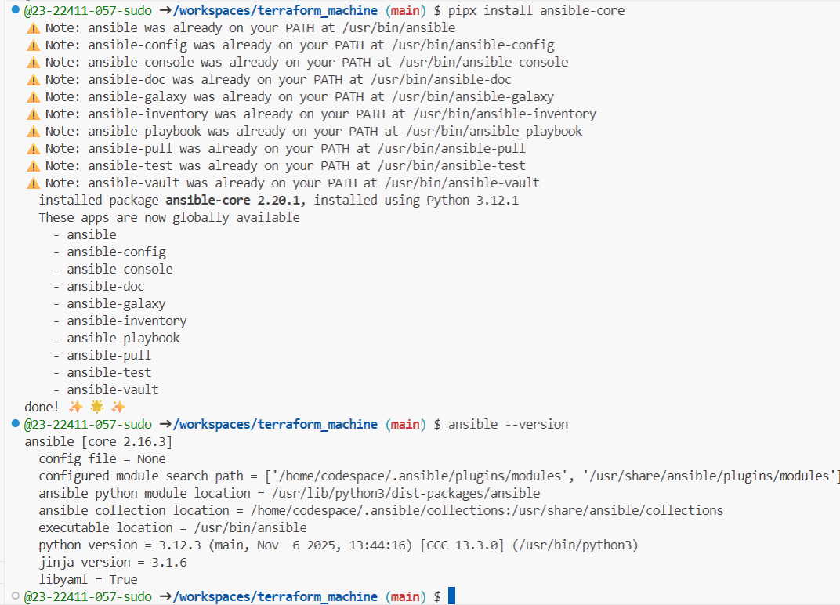
- Obtain the two public IPs of your EC2 instances:
task2_terraform_output_ips.png — terraform output listing at least 2 EC2 public IPs.
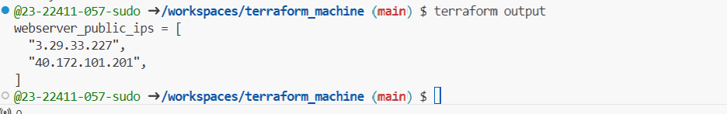
- Create Ansible inventory file hosts:
task2_hosts_created.png — confirmation that hosts file exists.
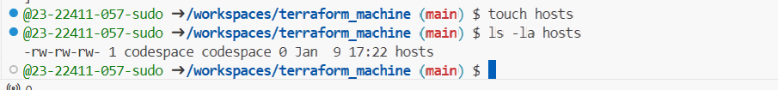
task2_hosts_initial.png — content of hosts with two IP lines.
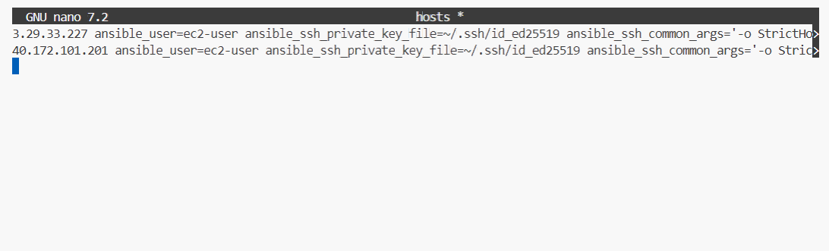
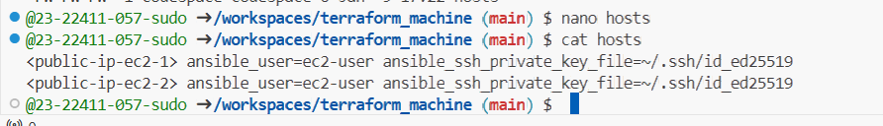

- Test connectivity:
task2_ansible_ping_initial.png — initial ansible all -i hosts -m ping output (success or failure).
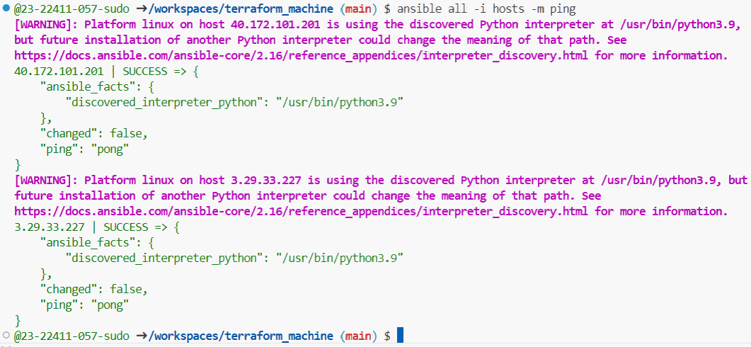
Task 3 - Scale to three instances & group-based inventory
You will expand to 3 web servers via Terraform’s count and restructure your inventory into groups.
- Update your Terraform module for webservers in main.tf to use count = 3:
task3_main_tf_count_3.png — main.tf snippet showing count = 3.
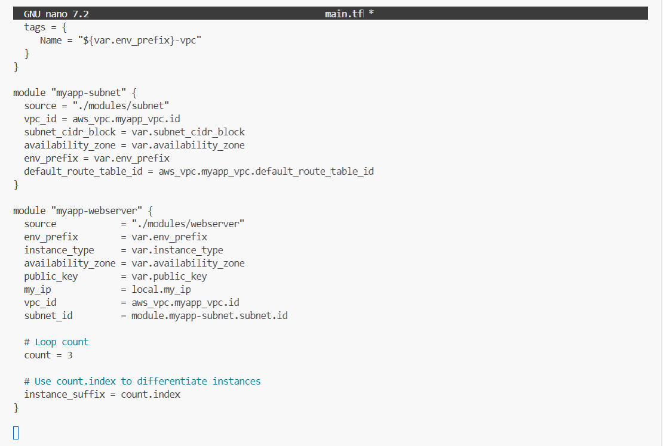
- Apply Terraform to get 3 instances:
task3_terraform_apply_3_instances.png — terraform apply output creating 3 instances.
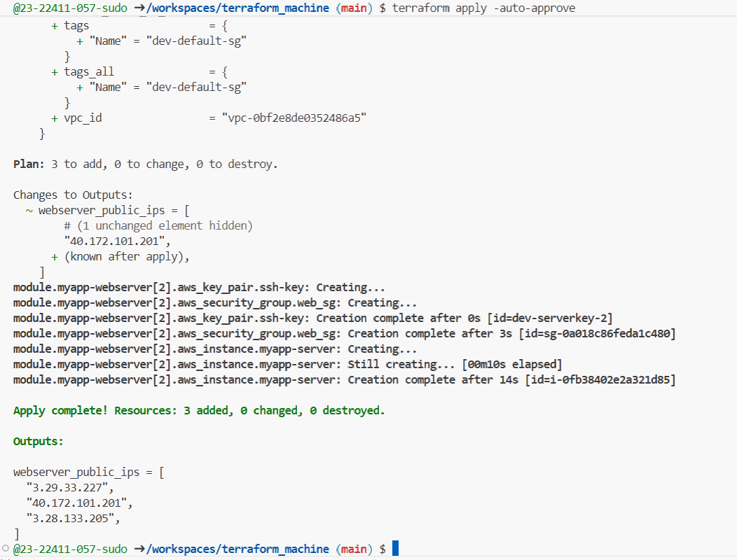
- Check outputs:
task3_terraform_output_3_ips.png — terraform output listing 3 public IPs.
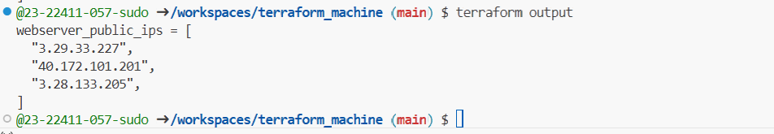
- Rewrite your hosts file using group definitions:
task3_hosts_grouped.png — hosts showing [ec2] and [droplet] with three IPs.
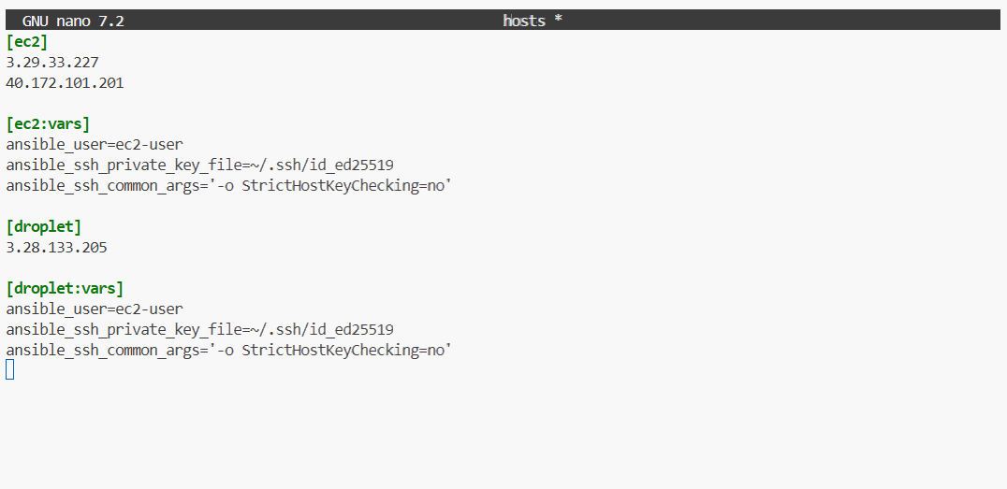
- Test group connectivity:
task3_ansible_ec2_ping.png — output of ansible ec2 -i hosts -m ping.
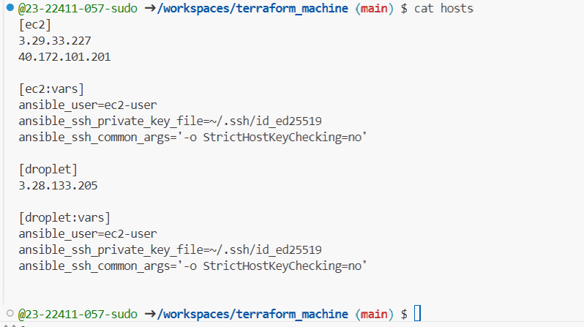
- Test single host by IP:
task3_ansible_single_ip_ping.png — ping output for one EC2 IP.
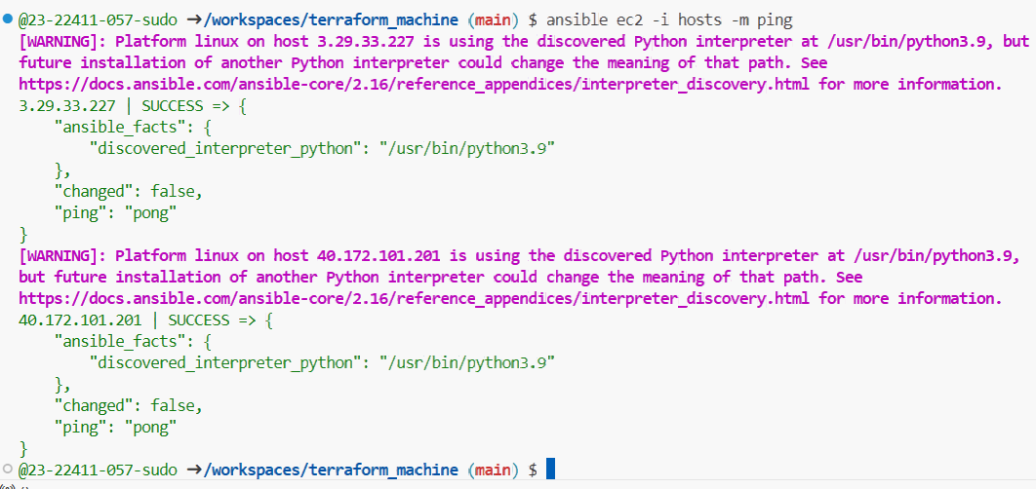
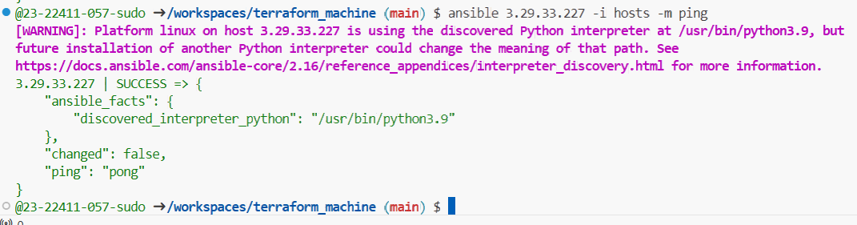
- Test droplet group:
task3_ansible_droplet_ping.png — ping output for droplet group.
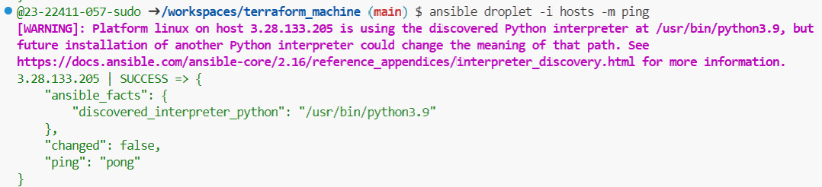
- Test all hosts:
task3_ansible_all_ping.png — ping output for all instances.
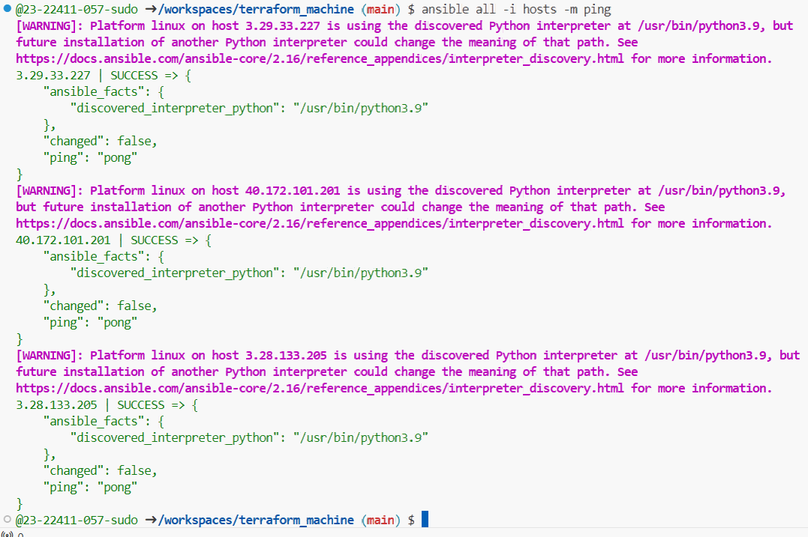

Task 4 – Global ansible.cfg & first nginx playbook
You will configure a global Ansible configuration file, then create a basic playbook for nginx.
- Create global Ansible configuration:
task4_global_ansible_cfg.png — content of ~/.ansible.cfg.
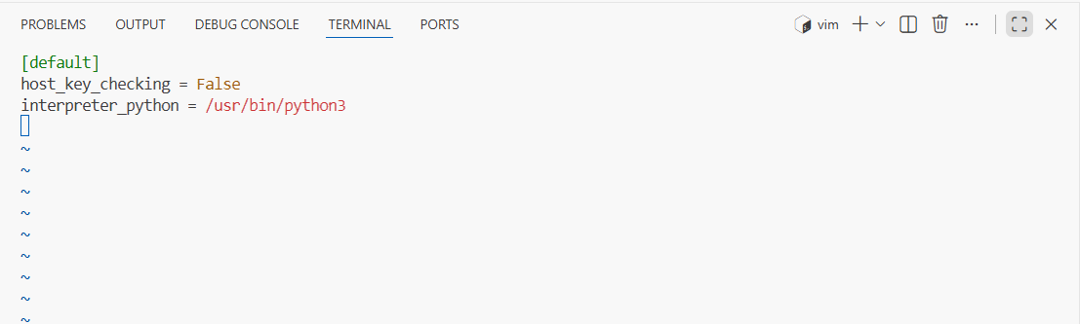
- Remove ansible_ssh_common_args from hosts (delete from all groups).
task4_hosts_without_common_args.png — hosts after removal.
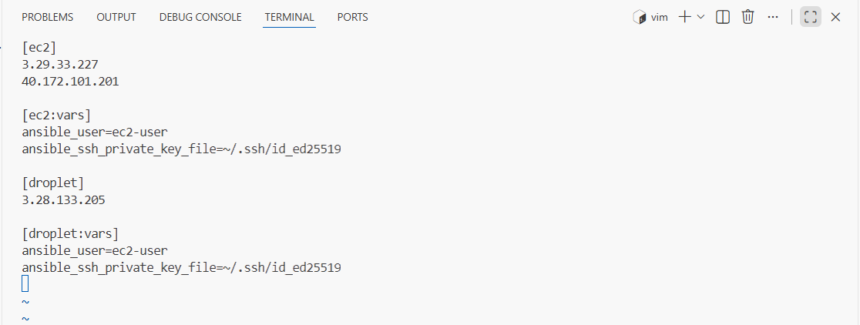
- Confirm connectivity:
task4_ansible_ping_after_cfg.png — ping output showing success, no strict host checking warning.
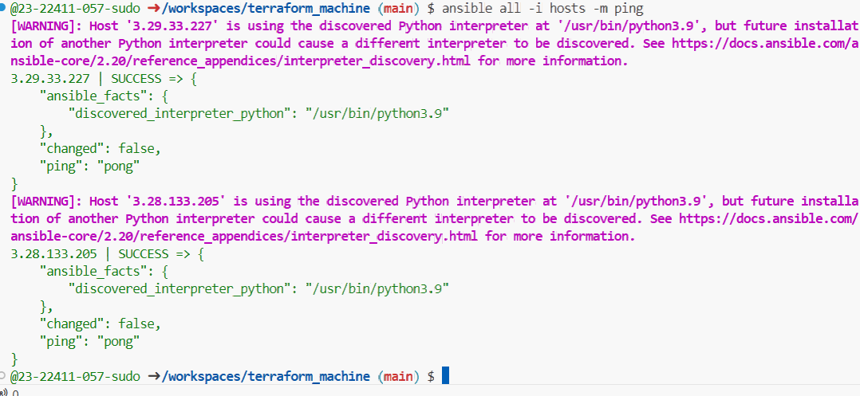
- Create my-playbook.yaml:
task4_my_playbook_created.png — existence of my-playbook.yaml.
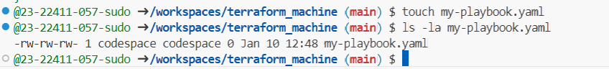
task4_my_playbook_ec2.png — content of my-playbook.yaml with hosts: ec2.
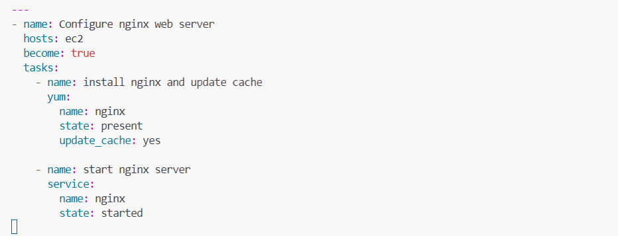
- Run the playbook on [ec2] group:
task4_ansible_play_ec2.png — playbook output for ec2 group.
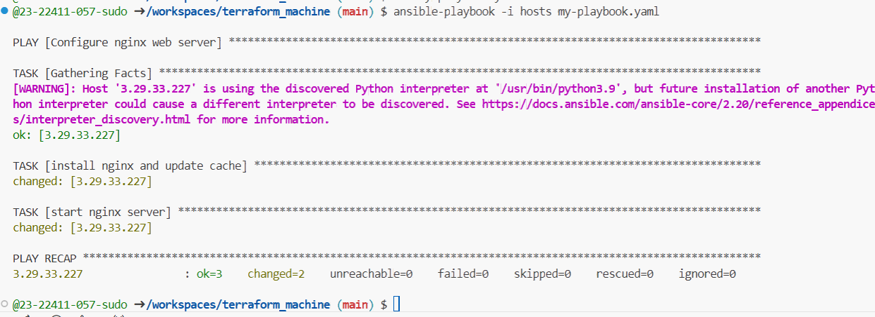
- Verify nginx default page on [ec2] servers by visiting http://<public-ip-ec2>.
task4_nginx_browser_ec2.png — browser showing nginx default page for an ec2 instance.

- Change target to droplet:
task4_my_playbook_droplet.png — playbook with hosts: droplet.
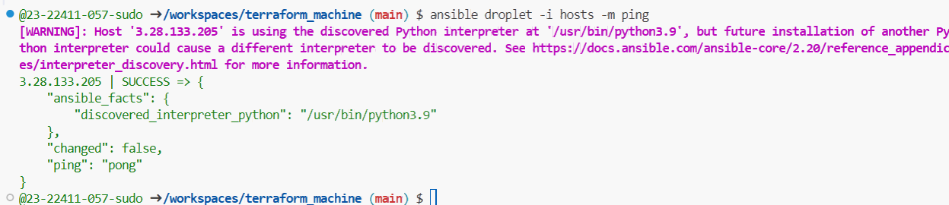
- Re-run:
task4_ansible_play_droplet.png — output of playbook for droplet group.
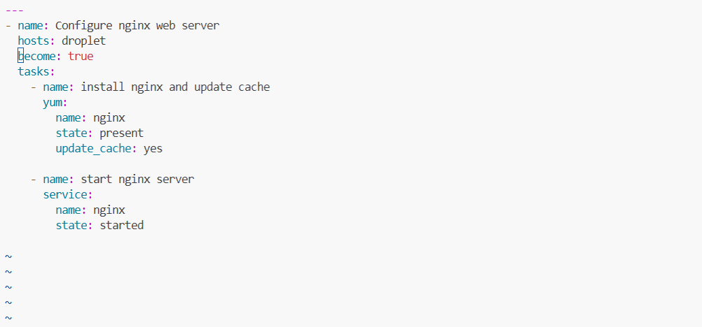
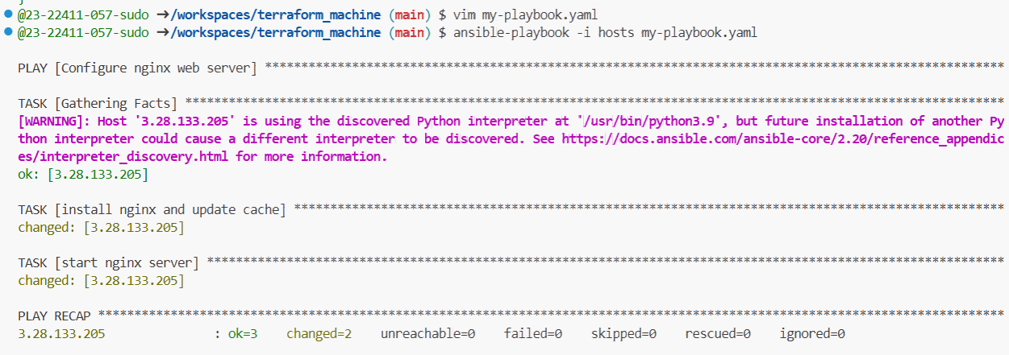
- Verify nginx default page on droplet:
task4_nginx_browser_droplet.png — browser showing nginx page on droplet.

Task 5 – Single nginx target group & HTTPS prerequisites
You will prepare project-level Ansible configuration and adjust nginx installation scope.
- Create project-level ansible.cfg in repo root:
task5_project_ansible_cfg_created.png — project ansible.cfg presence.
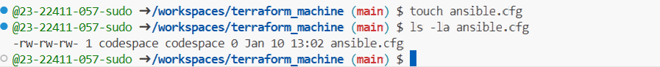
task5_project_ansible_cfg.png — project-level ansible.cfg content.
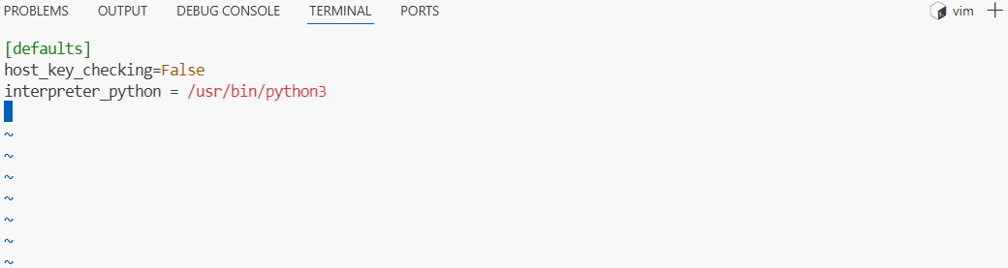
- Switch Terraform EC2 count back to 1:
task5_main_tf_count_1.png — snippet showing count = 1.
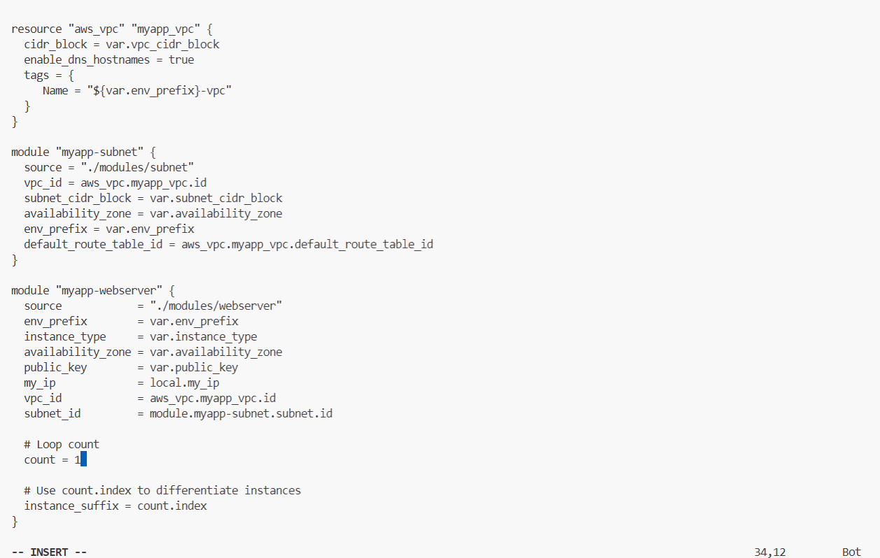
- Apply:
task5_terraform_apply_one_instance.png — apply output with one instance.
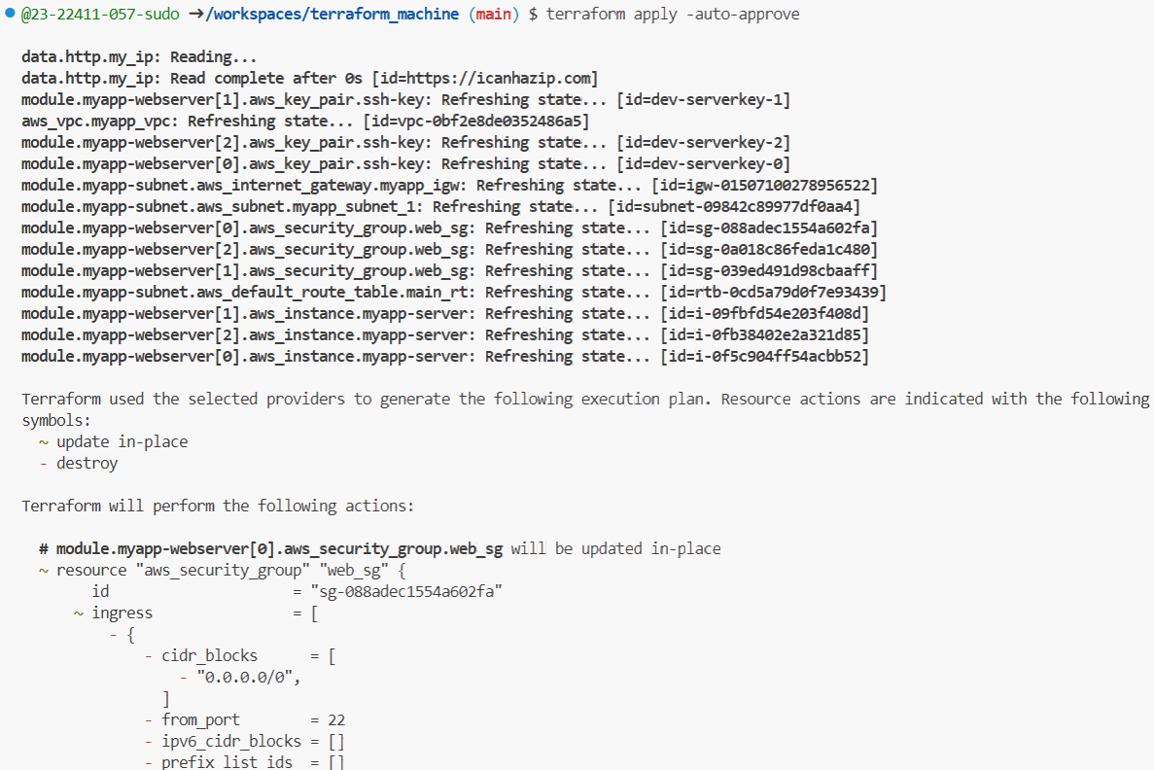
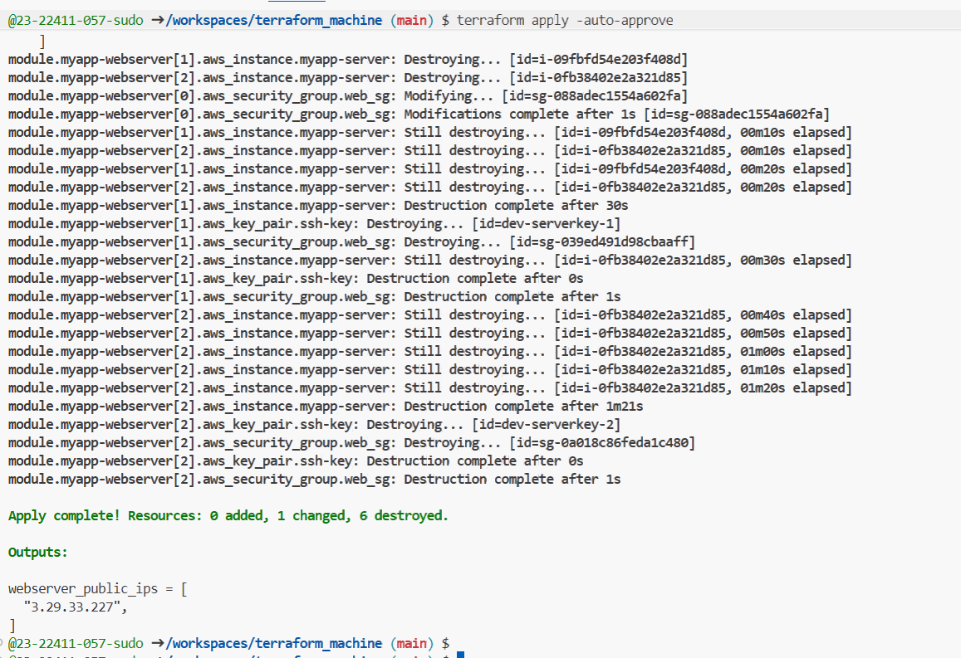
- Outputs:
task5_terraform_output_single_ip.png — single EC2 public IP.
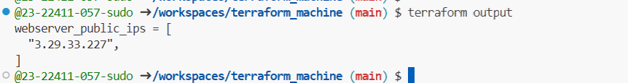
- Adjust hosts:
task5_hosts_nginx_group.png — hosts file for [nginx].
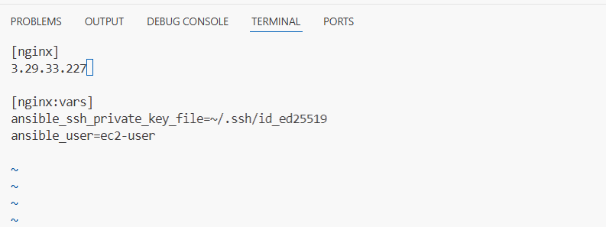
- Update my-playbook.yaml:
task5_my_playbook_nginx_group.png — playbook with hosts: nginx.
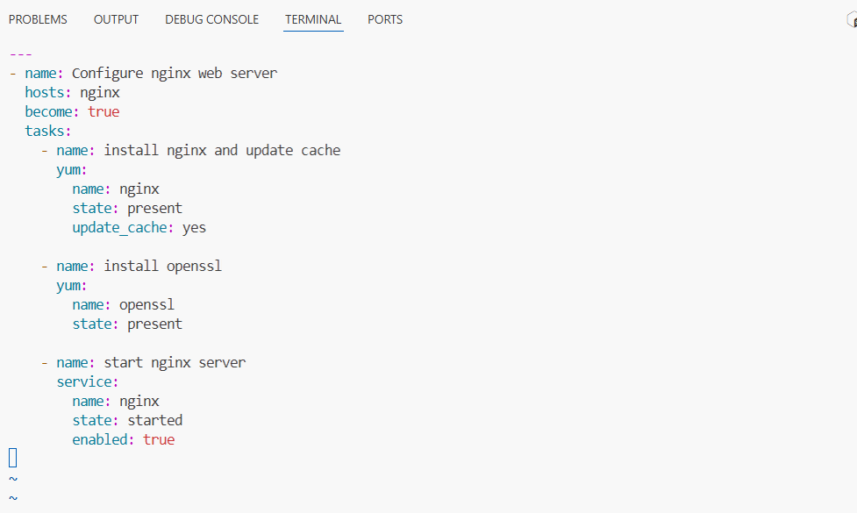
- Run the playbook:
task5_ansible_play_nginx_group.png — playbook output.
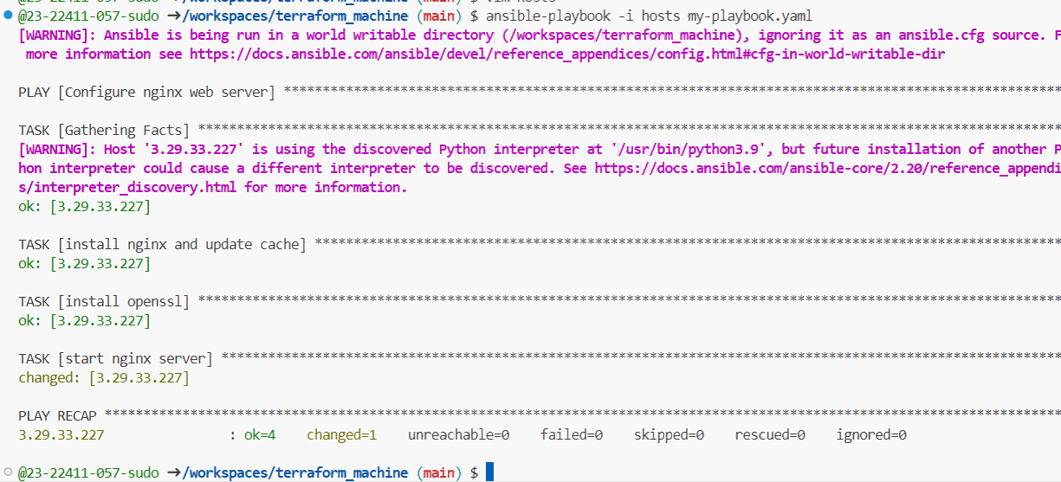
- Verify nginx default page at http://<public-ip>
task5_nginx_browser_single.png — browser view.
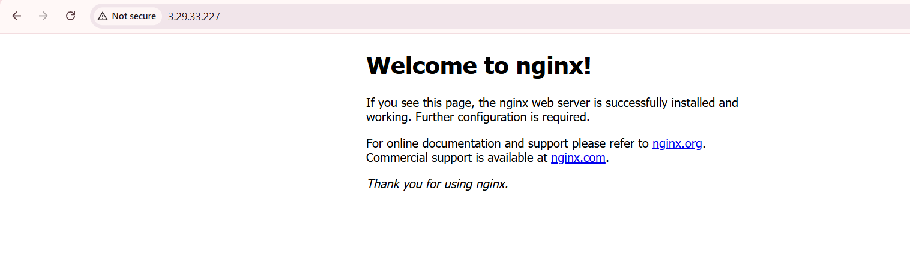
Task 6 - Ansible-managed SSL certificates
Extend your playbook to generate self-signed SSL certificates using dynamic public IP.
- Append this play after the nginx play in my-playbook.yaml:
task6_my_playbook_ssl_section.png — SSL block in my-playbook.yaml.
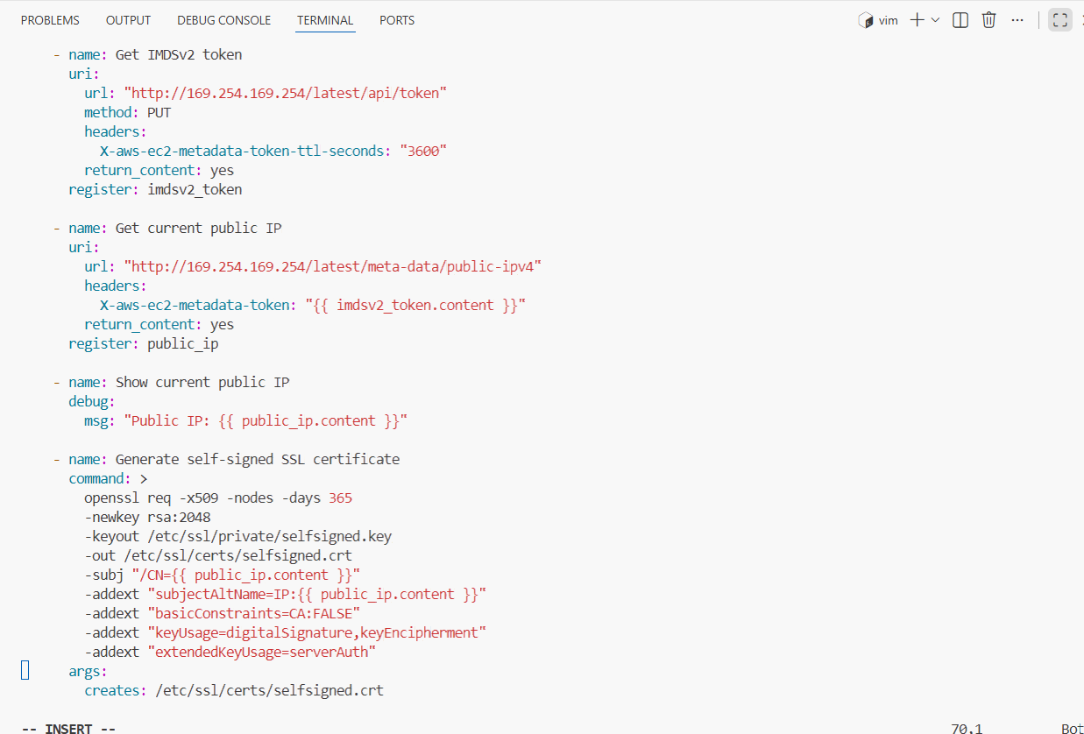
- Run:
task6_ansible_play_ssl.png — SSL tasks output.
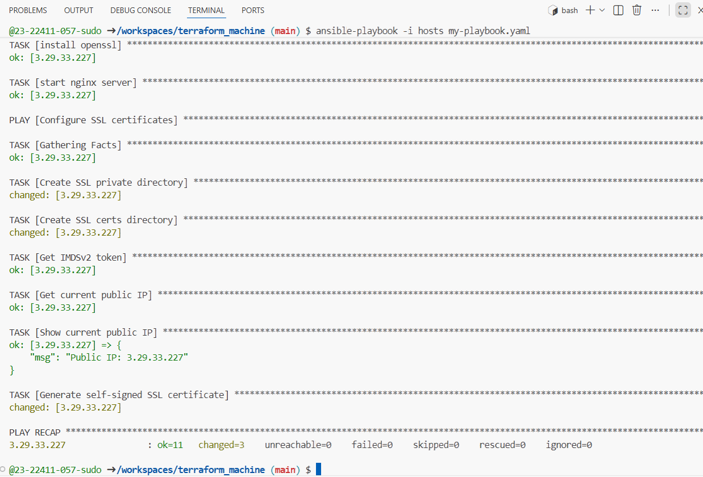
- SSH and verify:
task6_ssl_cert_file.png — cat /etc/ssl/certs/selfsigned.crt.
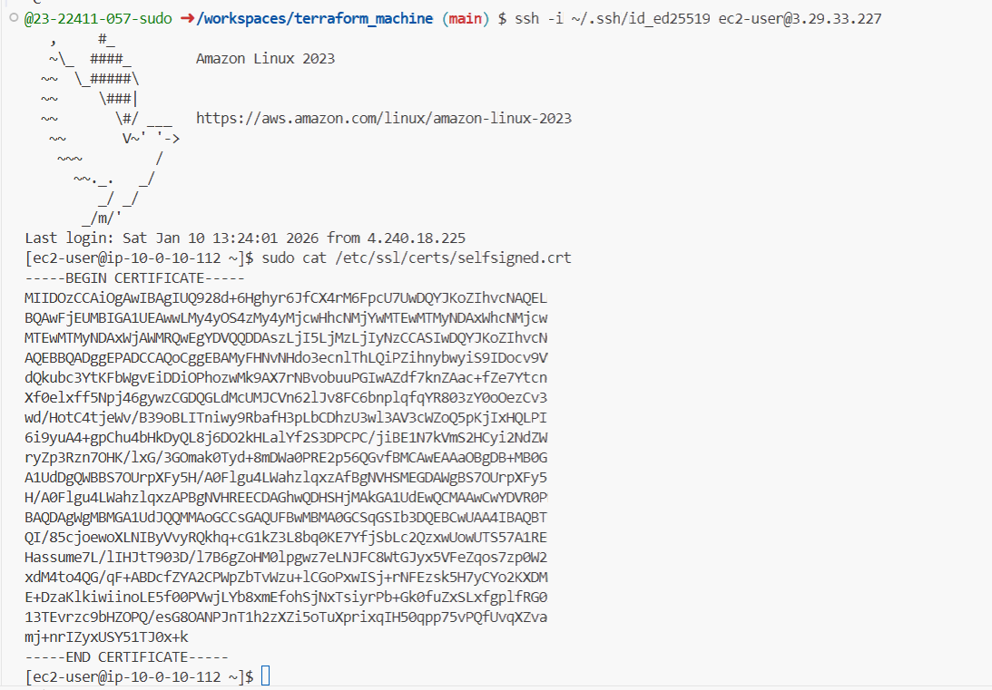
task6_ssl_key_file.png — cat /etc/ssl/private/selfsigned.key.
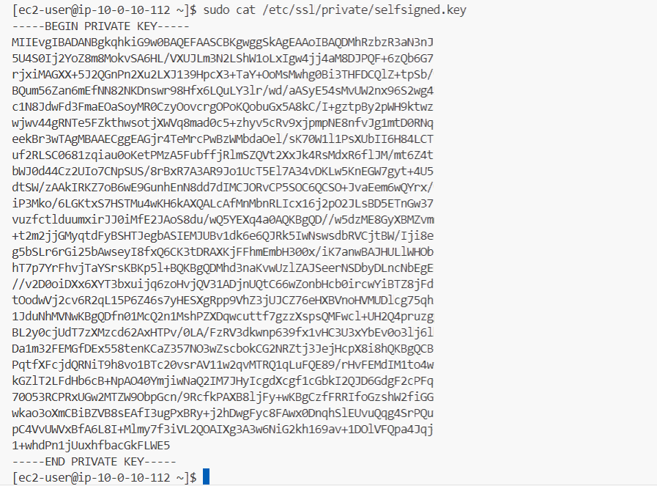
Task 7 - PHP front-end deployment with templates
Deploy a PHP application and Nginx configuration using Ansible copy and template.
- Create directories and files:
task7_files_templates_created.png — ls -R showing files/index.php and templates/nginx.conf.j2
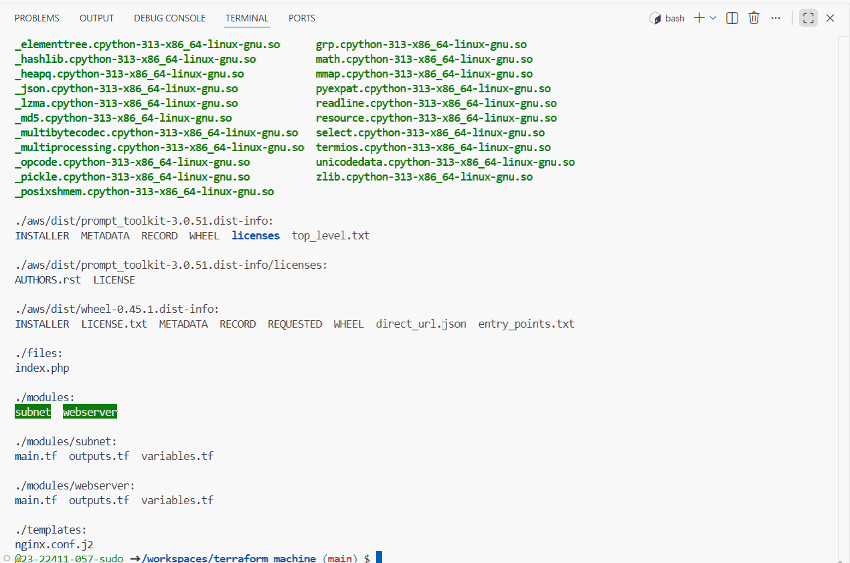.
- Fill files/index.php with the following PHP metadata page:
task7_index_php_content.png — content of files/index.php in editor or cat.
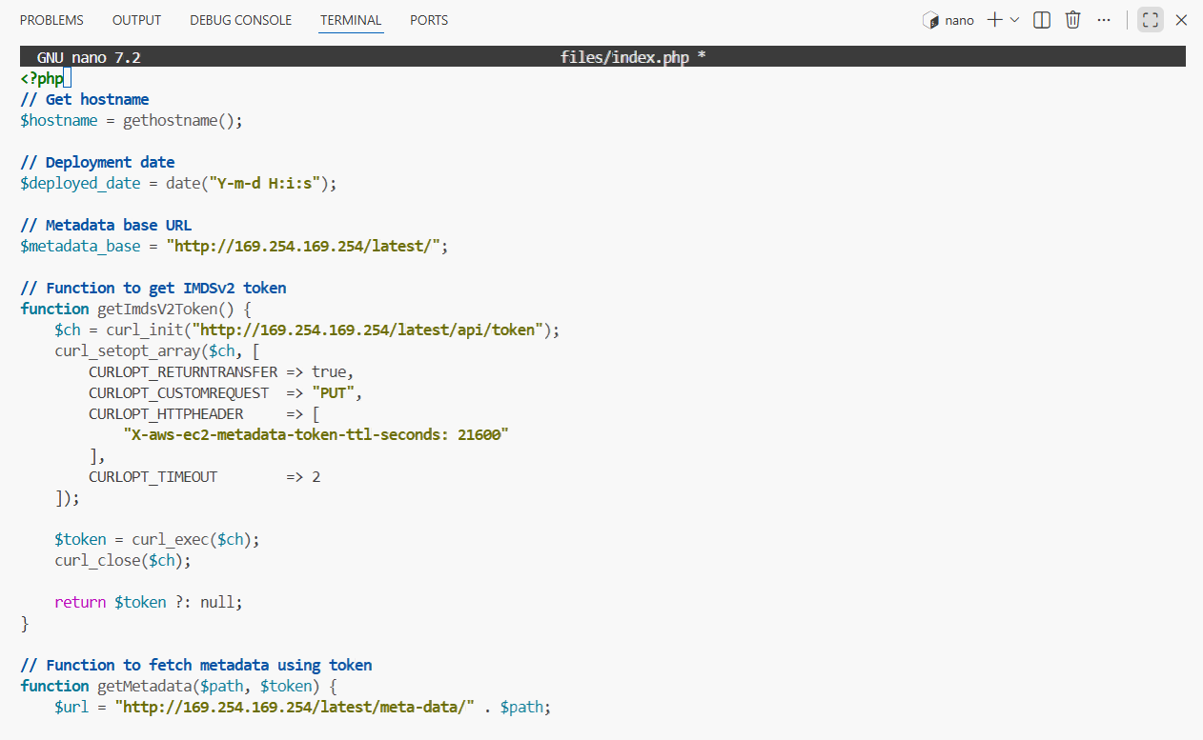
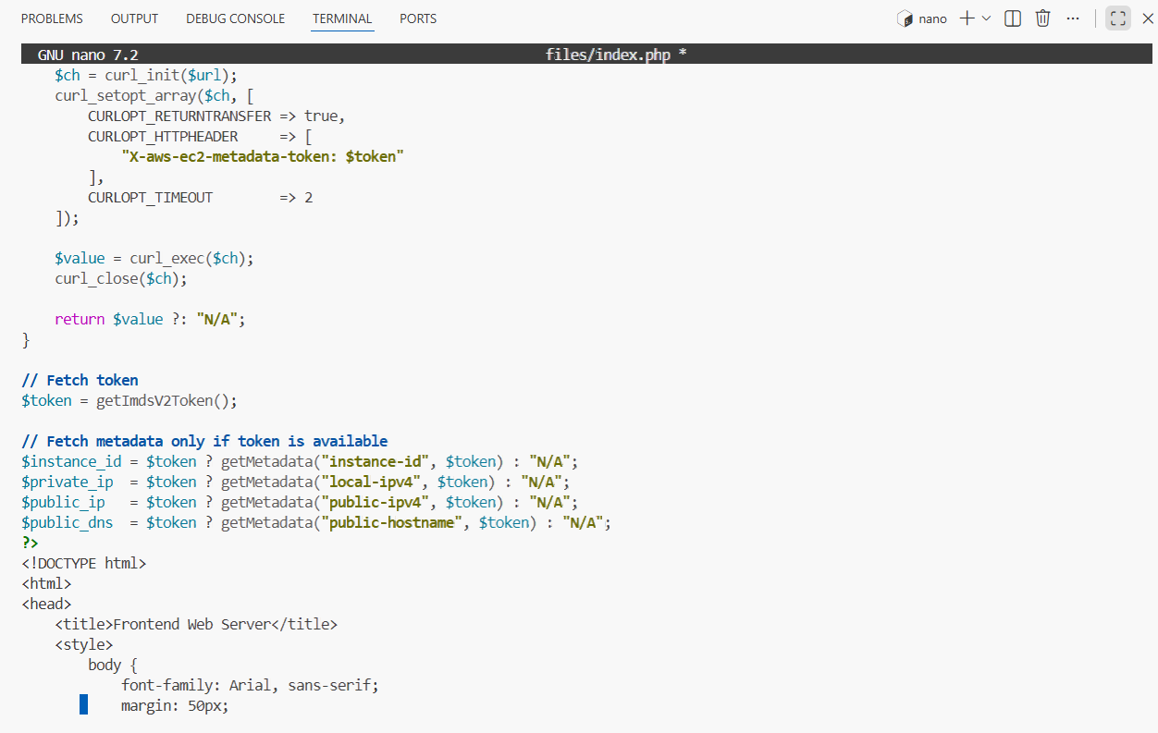
- Fill templates/nginx.conf.j2 with the following Nginx configuration template:
task7_nginx_conf_template.png — content of templates/nginx.conf.j2.
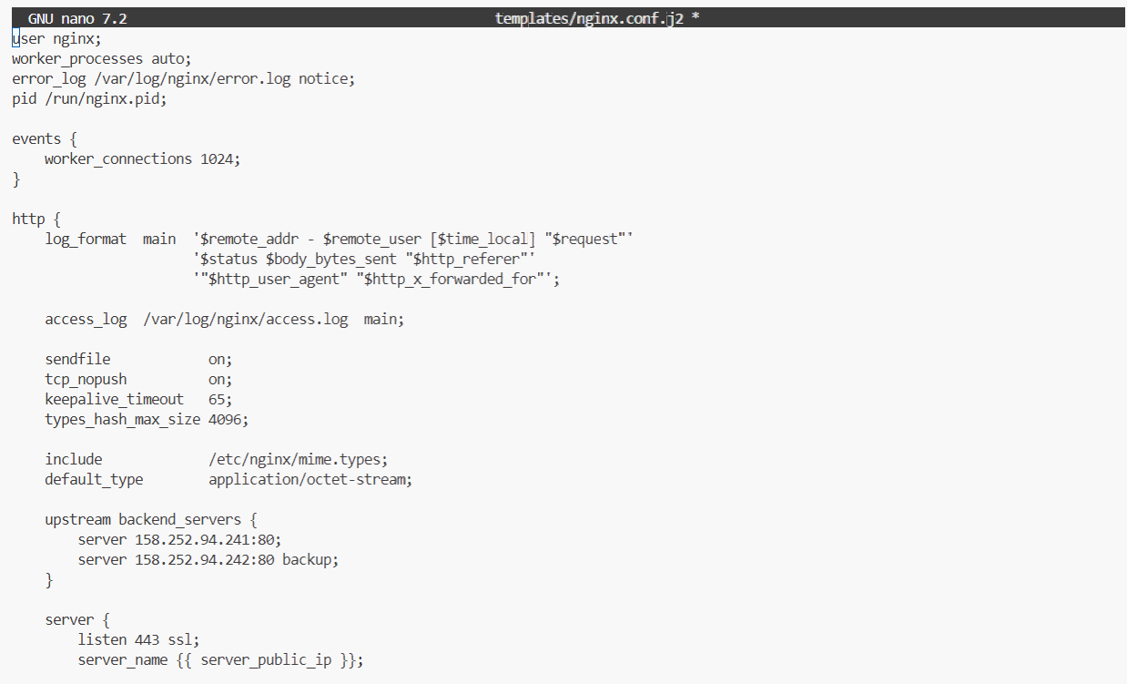
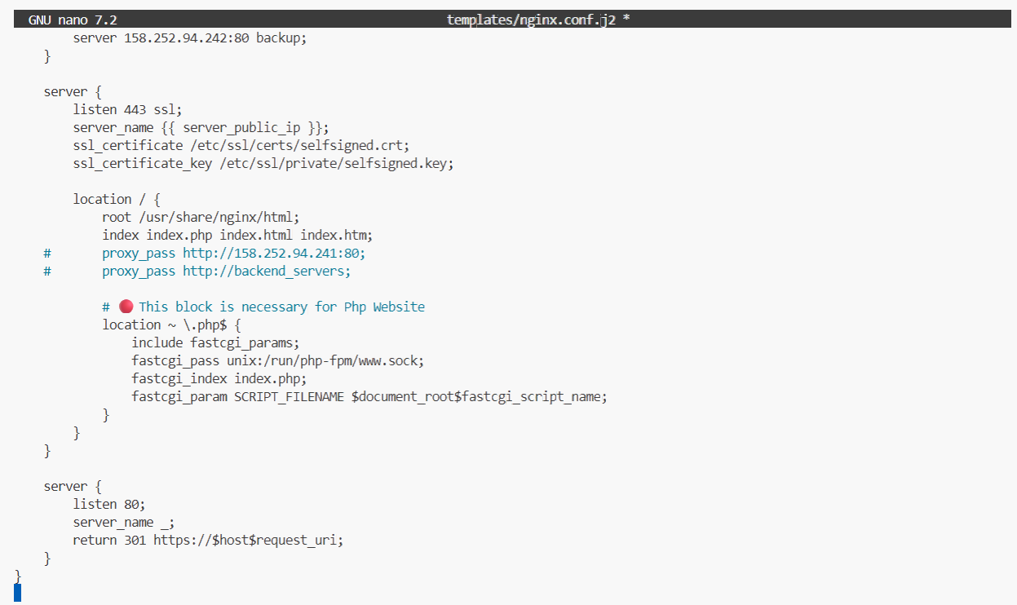

- Add this play to my-playbook.yaml:
task7_my_playbook_web_deploy.png — updated my-playbook.yaml including this play.
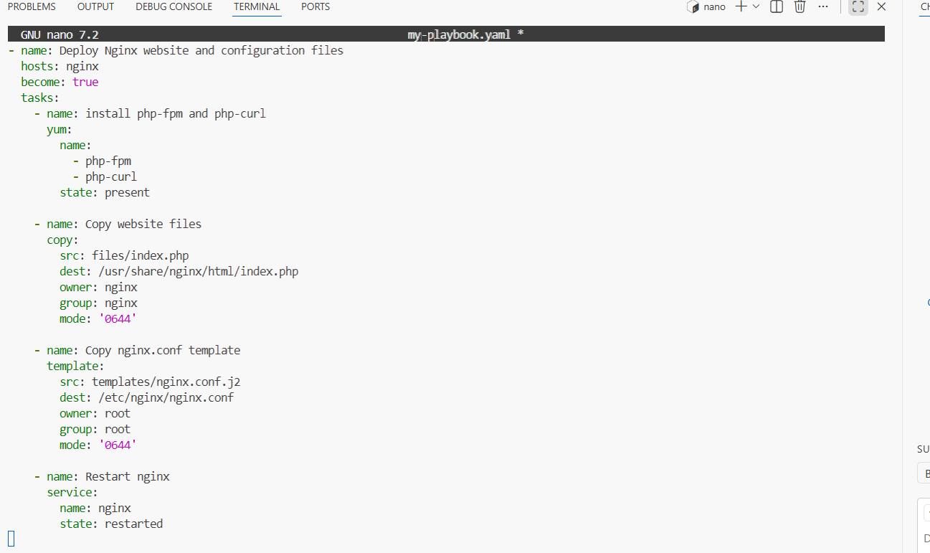
- Run the playbook:
task7_ansible_play_web_deploy.png — playbook output showing PHP/nginx tasks executed.
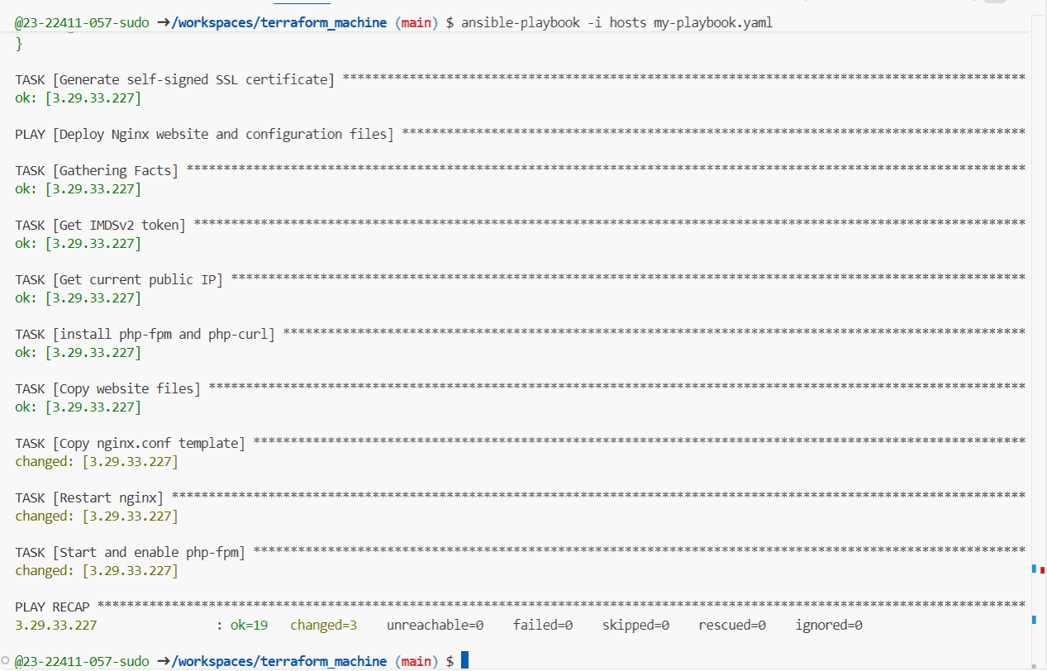
- Visit https://<public-ip>:
task7_php_https_browser.png — browser showing PHP web page via HTTPS.
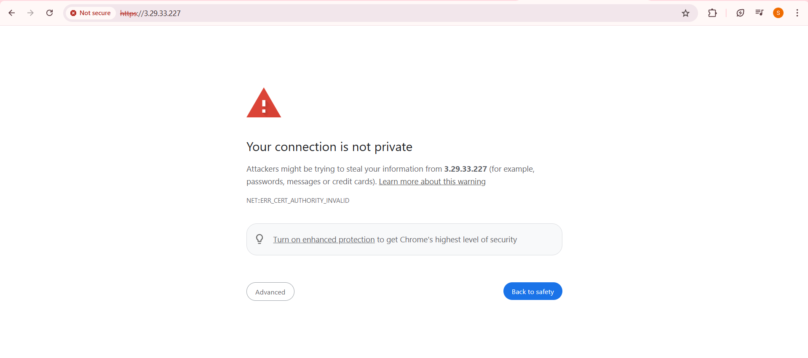
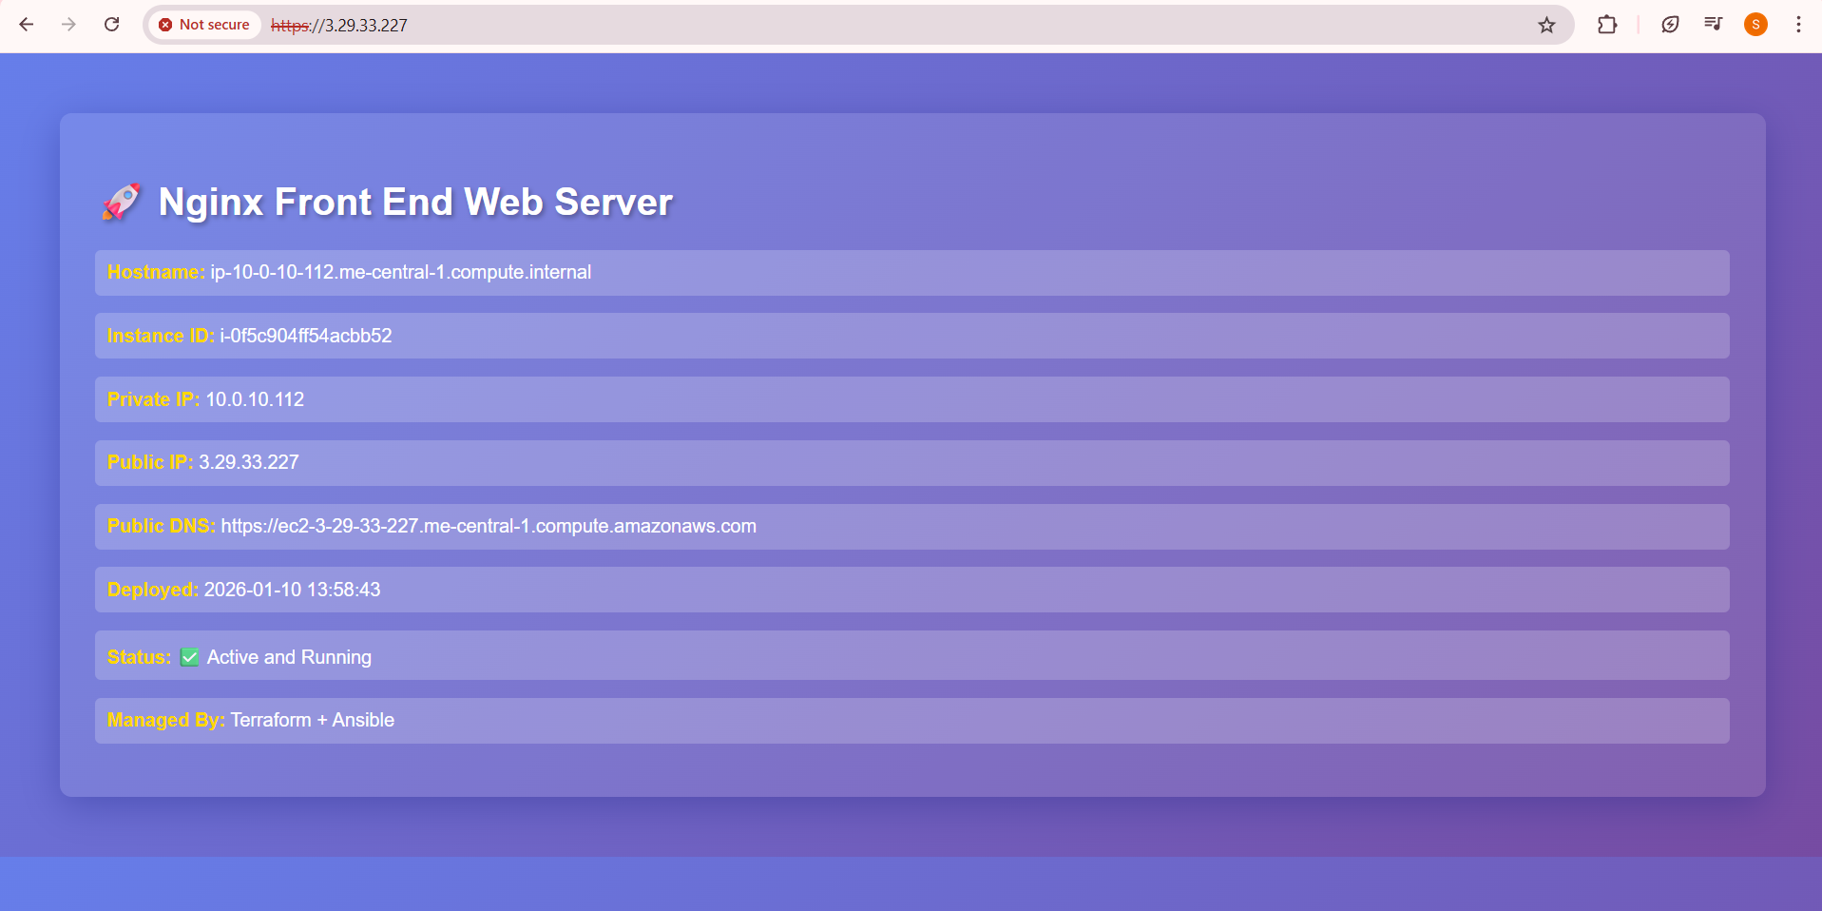
Task 8 – Docker & Docker Compose provisioning via Ansible
Deploy Docker and Docker Compose on a new EC2 instance.
- Destroy old infrastructure:
task8_terraform_destroy_old.png — destroy output for old stack.
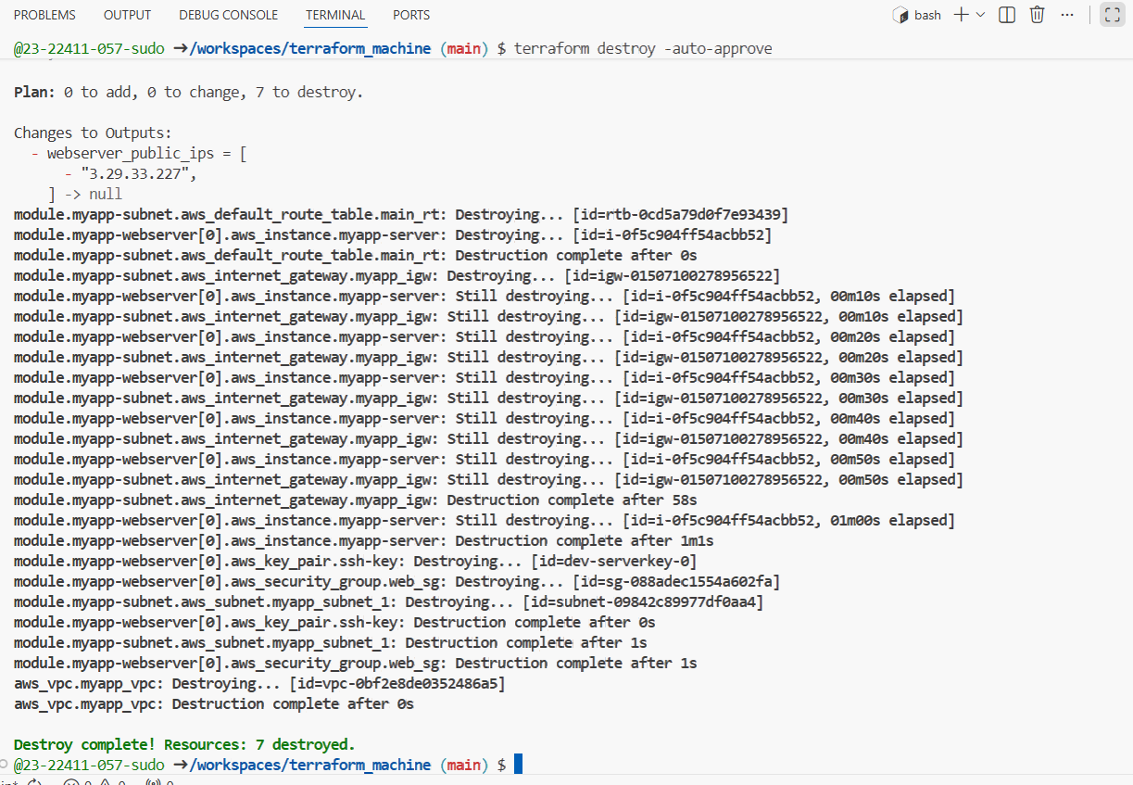
- Recreate fresh infrastructure (1 instance):
task8_terraform_apply_docker_instance.png — new apply.
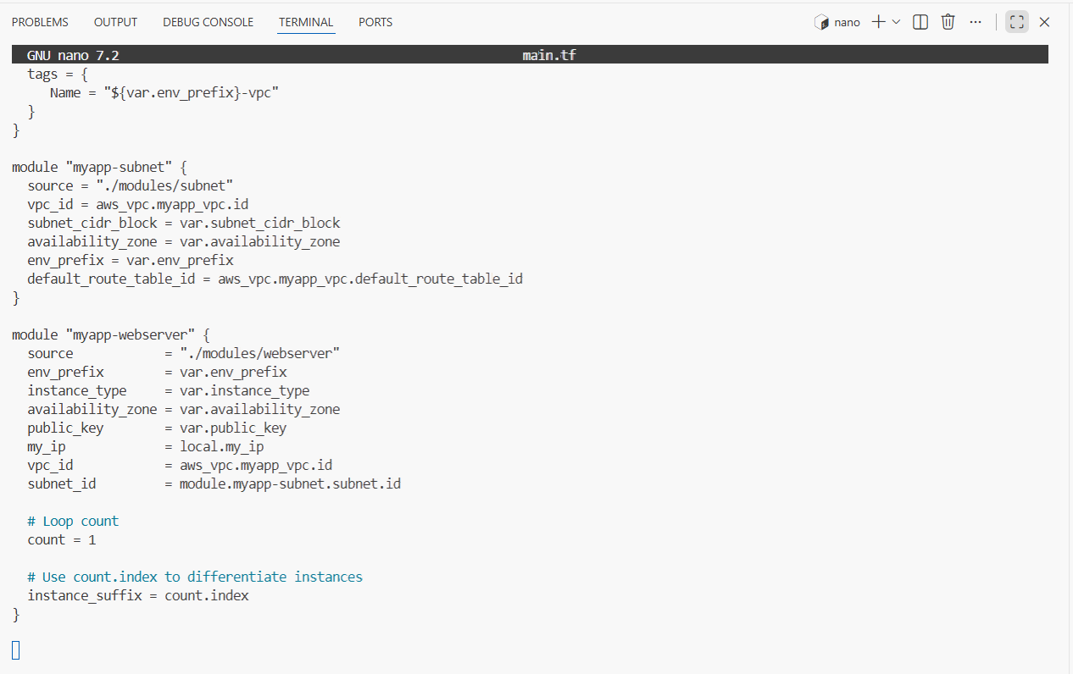
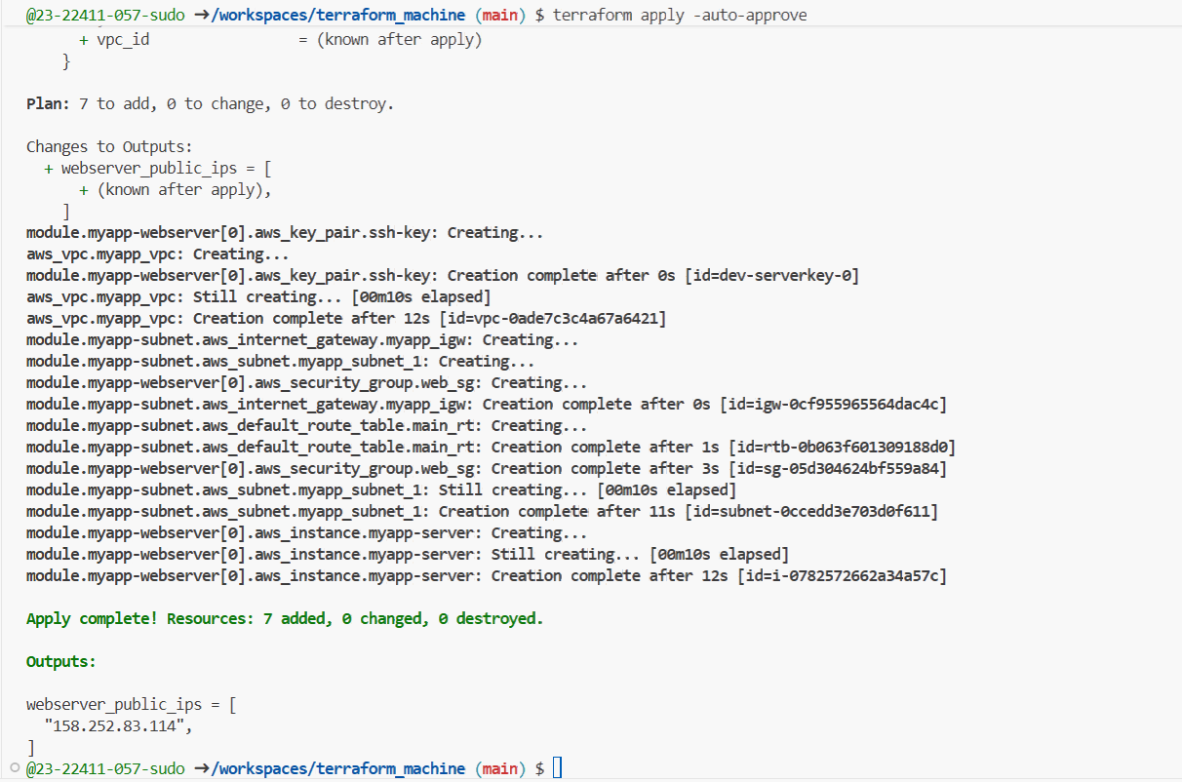
task8_terraform_output_new_ip.png — output showing new instance IP.
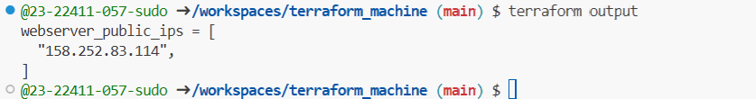
- Update hosts:
task8_hosts_docker_servers.png — hosts file showing [docker_servers].
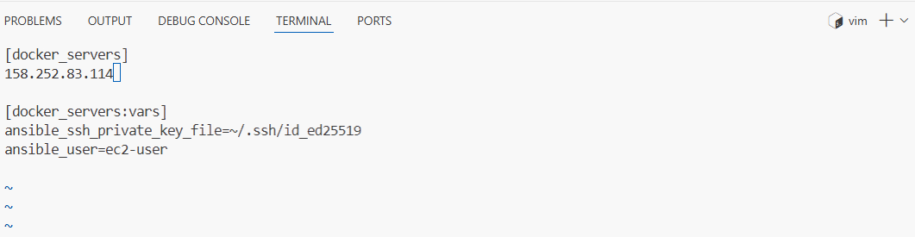
- Replace my-playbook.yaml content with:
task8_my_playbook_docker.png — new Docker playbook content.
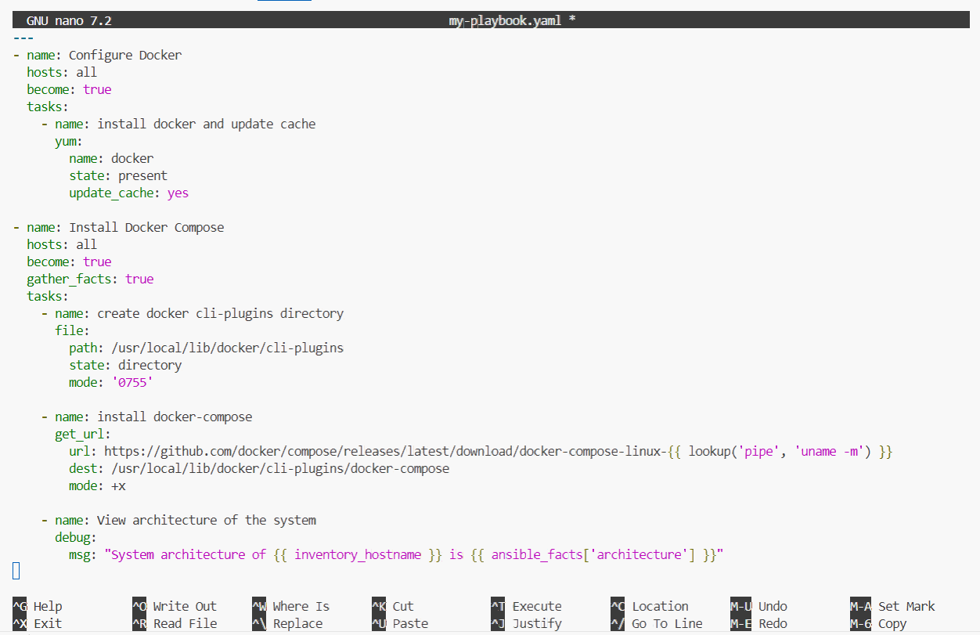
- Run the play:
task8_ansible_play_docker.png — playbook output installing Docker and Compose.
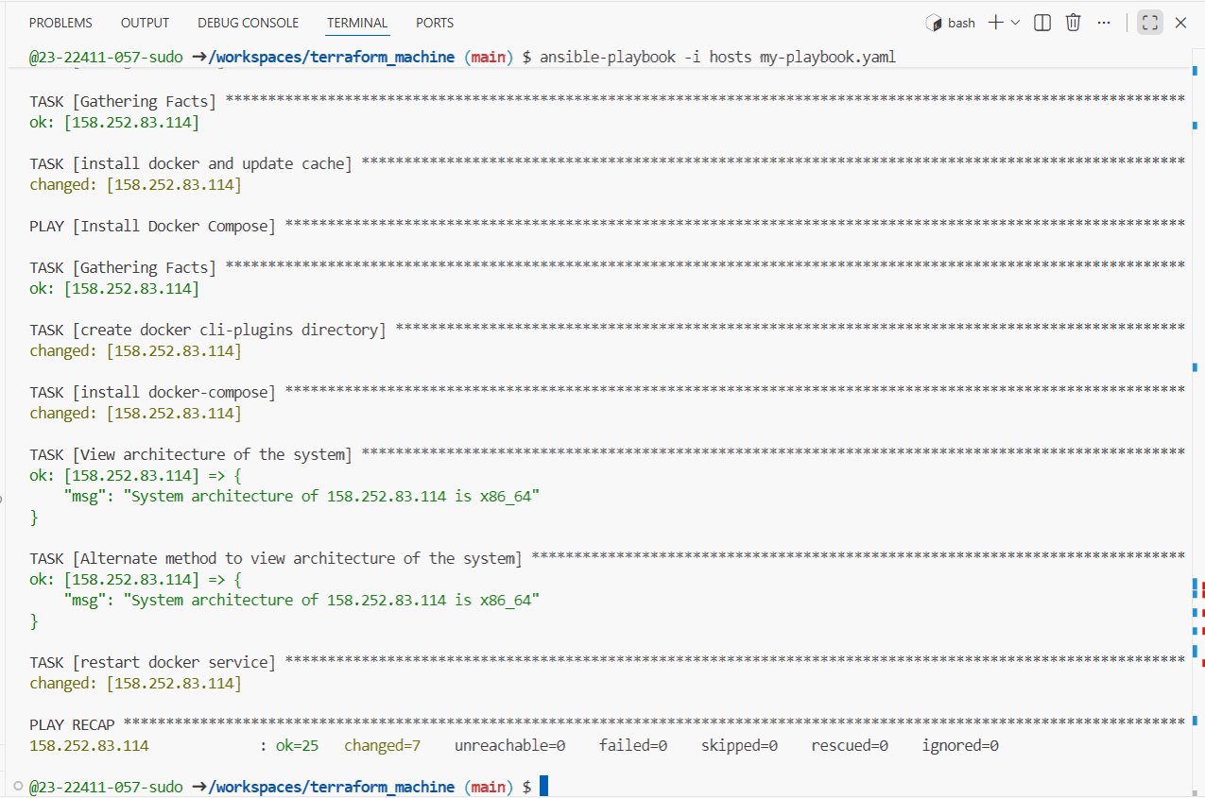
- Verify Docker:
task8_docker_ps_remote.png — sudo docker ps output from EC2 instance.
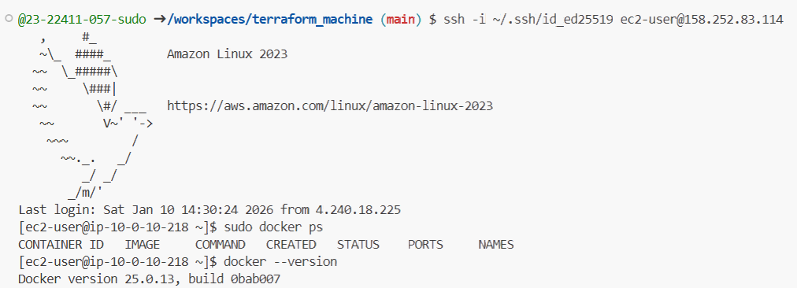
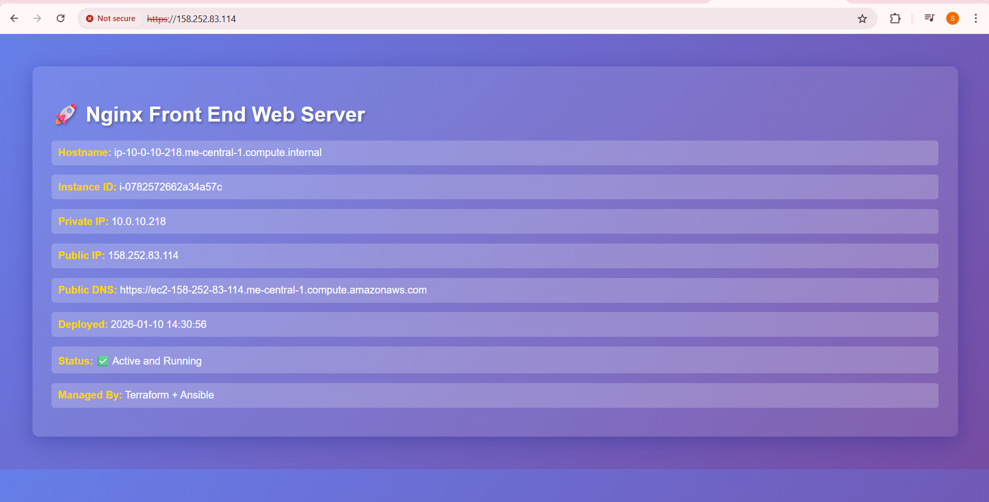
Task 9 – Gitea Docker stack via Ansible + Terraform security group update
Run containers for Gitea + Postgres and open port 3000 in the security group.
- Extend my-playbook.yaml by appending:
task9_my_playbook_add_user_to_docker.png — new play appended in my-playbook.yaml.
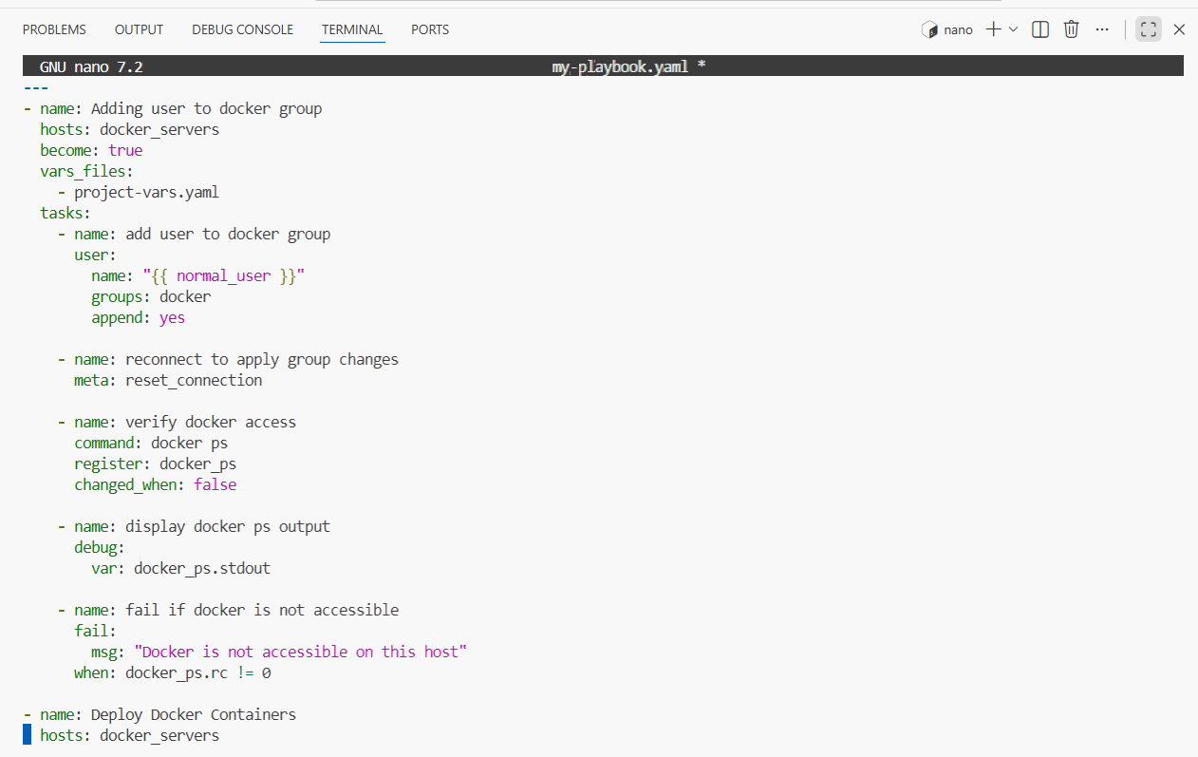
- Create project-vars.yaml:
task9_project_vars.png — content of project-vars.yaml.
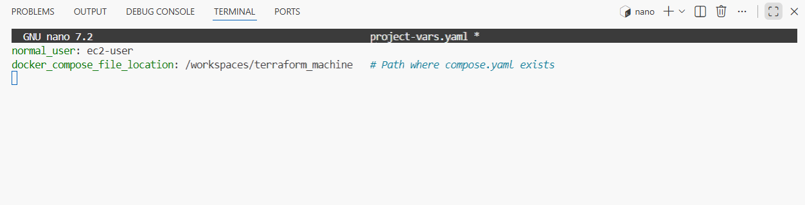
- Add the deploy containers play:
task9_my_playbook_deploy_containers.png — final my-playbook.yaml with Docker deploy play.
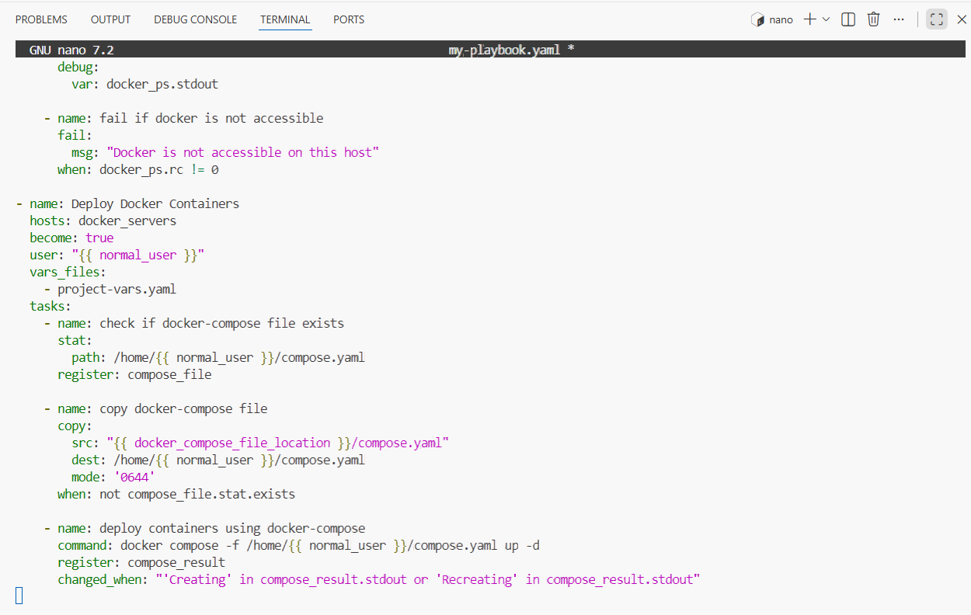
- Create compose.yaml in repo root:
task9_compose_yaml.png — content of compose.yaml.
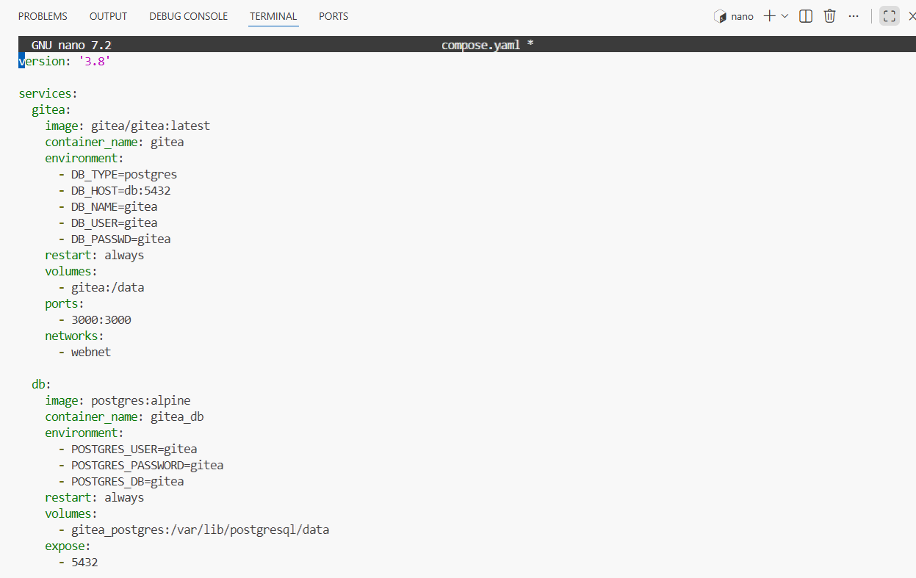
- Run playbook and visit the public-ip on your browser but webpage will not be shown due to permission issue:
task9_ansible_play_gitea.png — playbook output showing Gitea/db containers created.
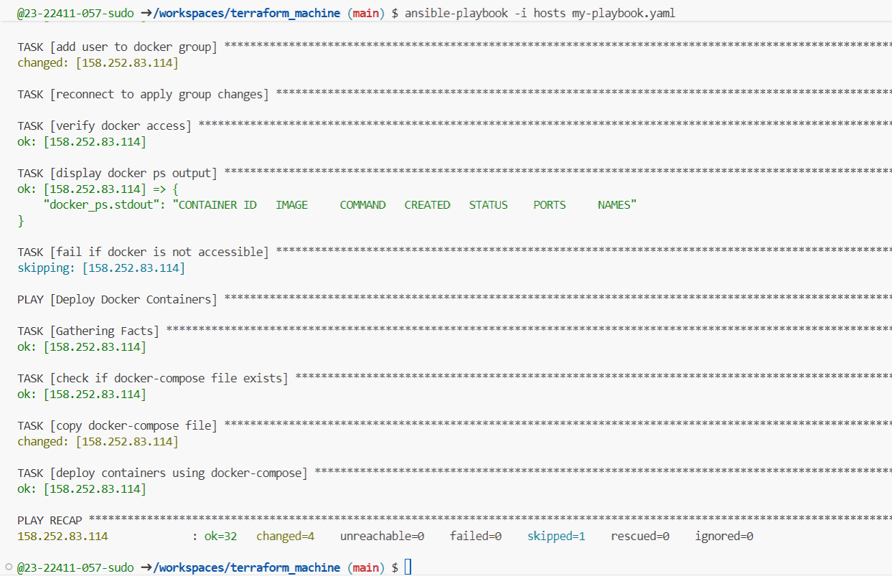
- Update security group in modules/webserver/main.tf to add port 3000:
task9_sg_ingress_3000.png — web_sg snippet showing 3000/tcp ingress.
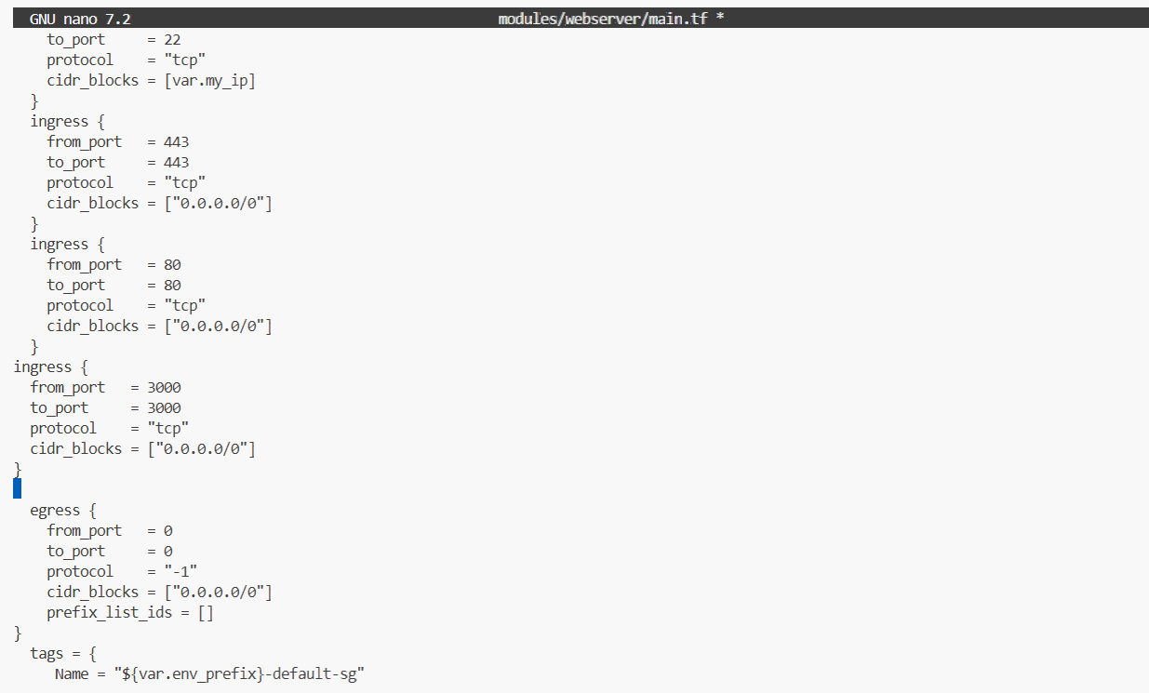
- Apply:
task9_terraform_apply_sg_3000.png — apply output updating SG.
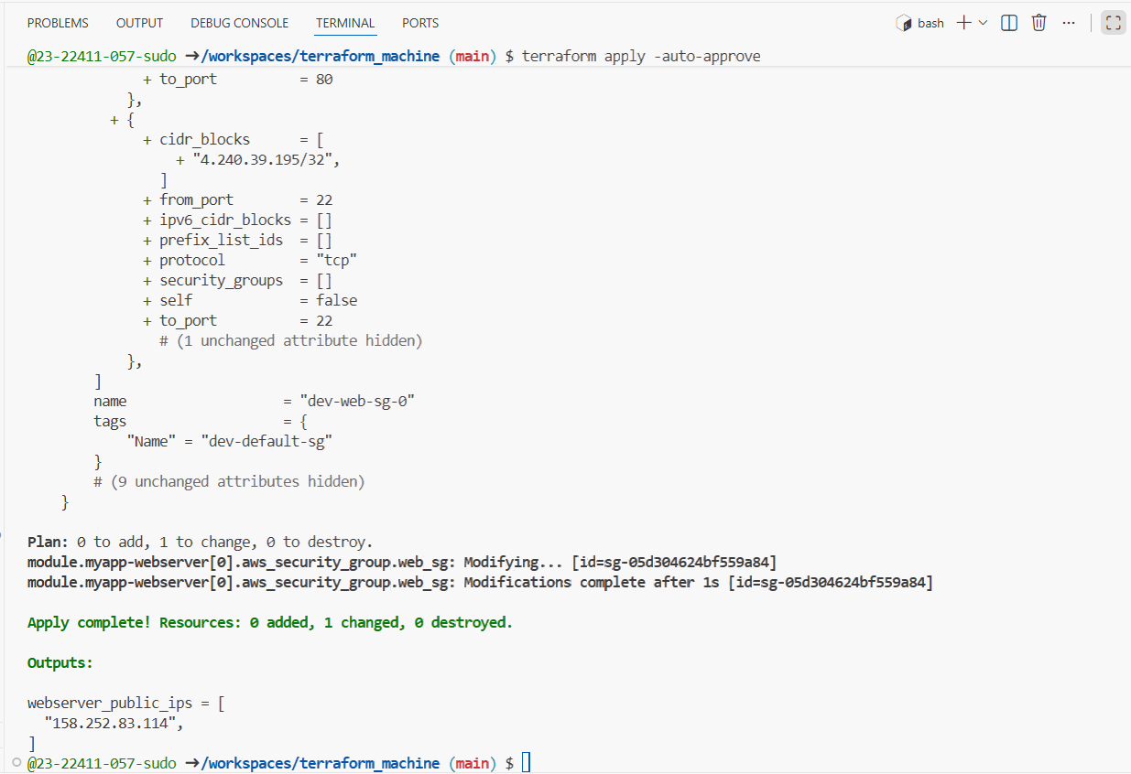
- Access Gitea:
task9_gitea_browser.png — browser showing Gitea UI.
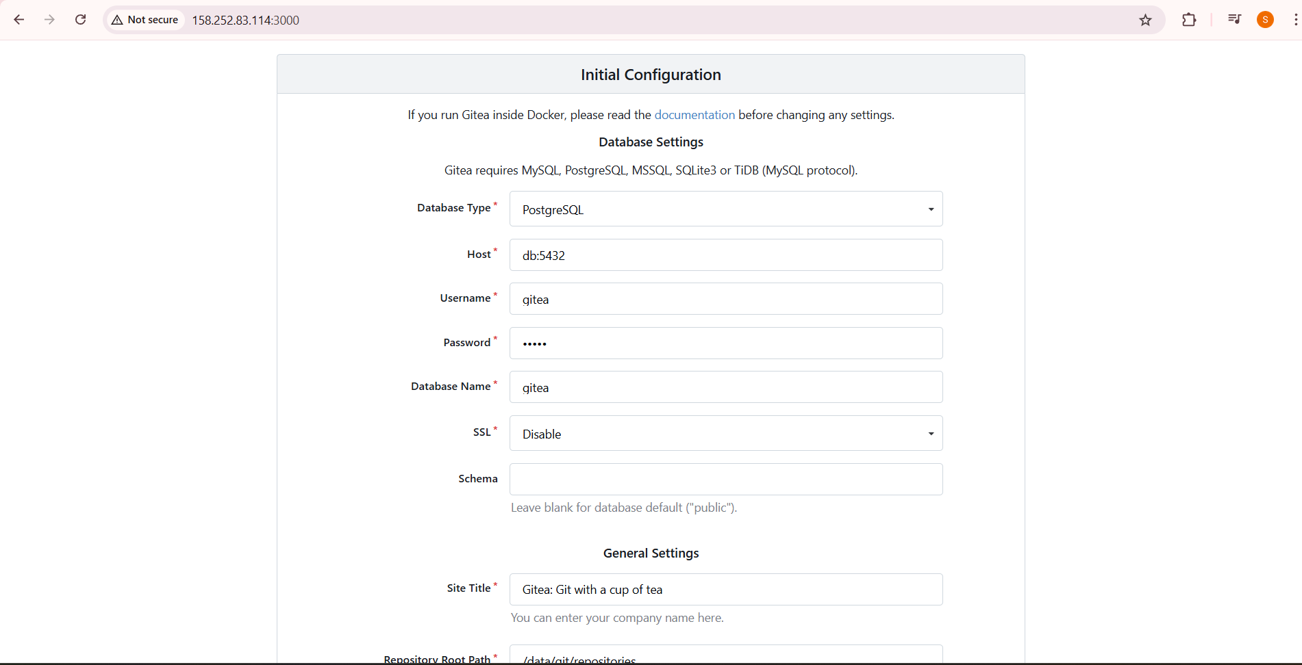
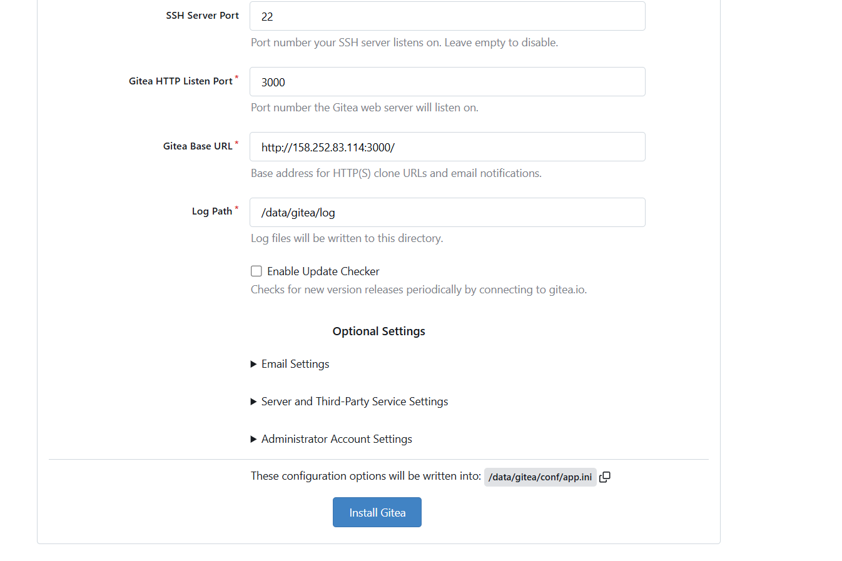
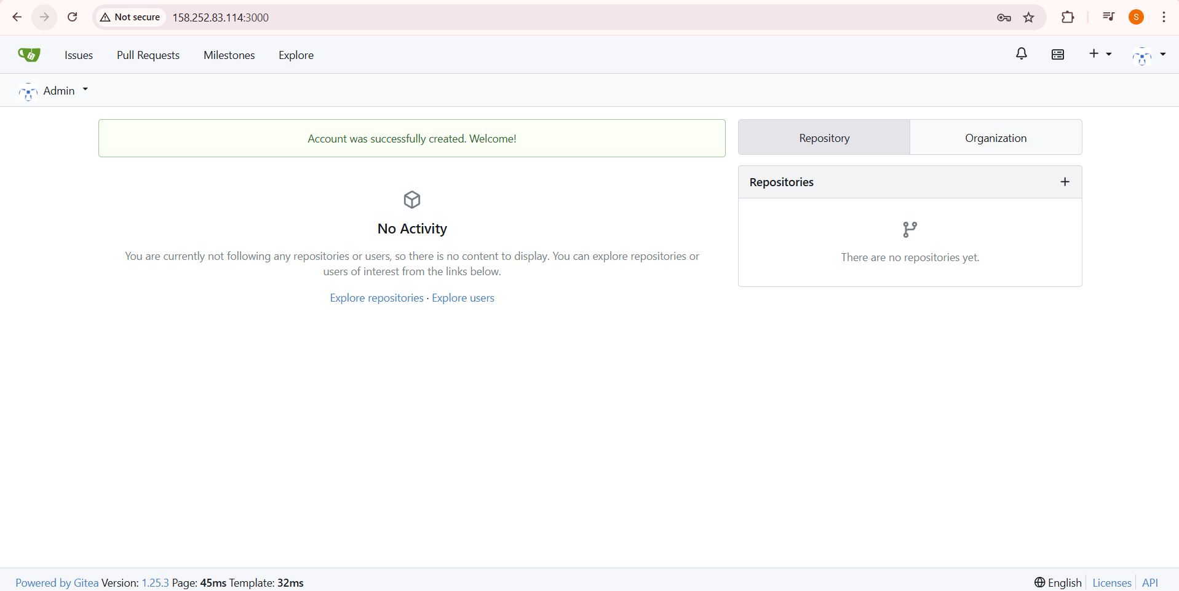
Task 10 – Automating Ansible with Terraform (null_resource)
Have Terraform trigger Ansible automatically after EC2 creation.
- Add null_resource to main.tf:
task10_null_resource_main_tf.png — main.tf showing null_resource block.
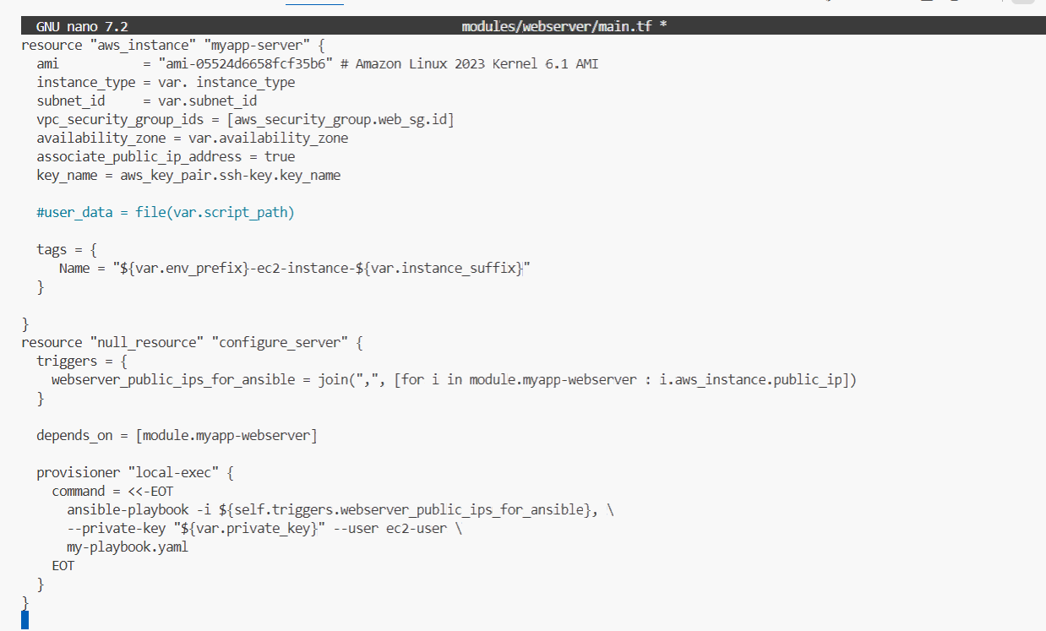
- Destroy and recreate infrastructure:
task10_terraform_destroy_before_null.png — destroy output.
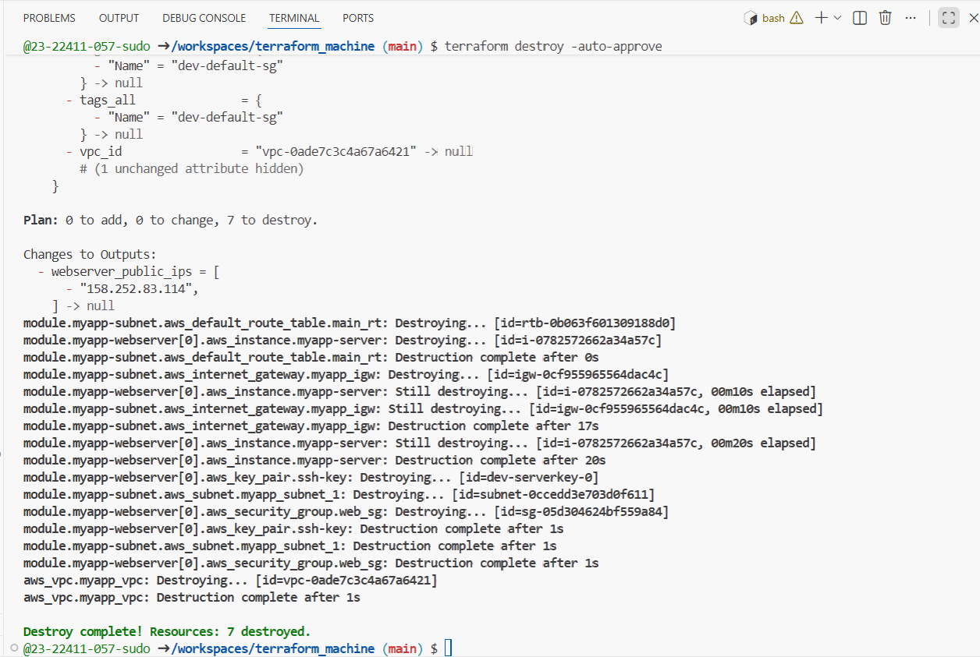
task10_terraform_apply_with_local_exec.png — apply output showing local-exec / Ansible execution.
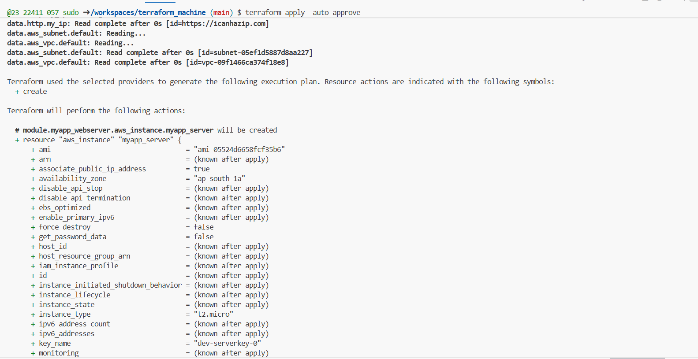
- If Ansible fails due to readiness, add a wait play at the top of my-playbook.yaml:
task10_my_playbook_wait_for_ssh.png — top wait play in file.
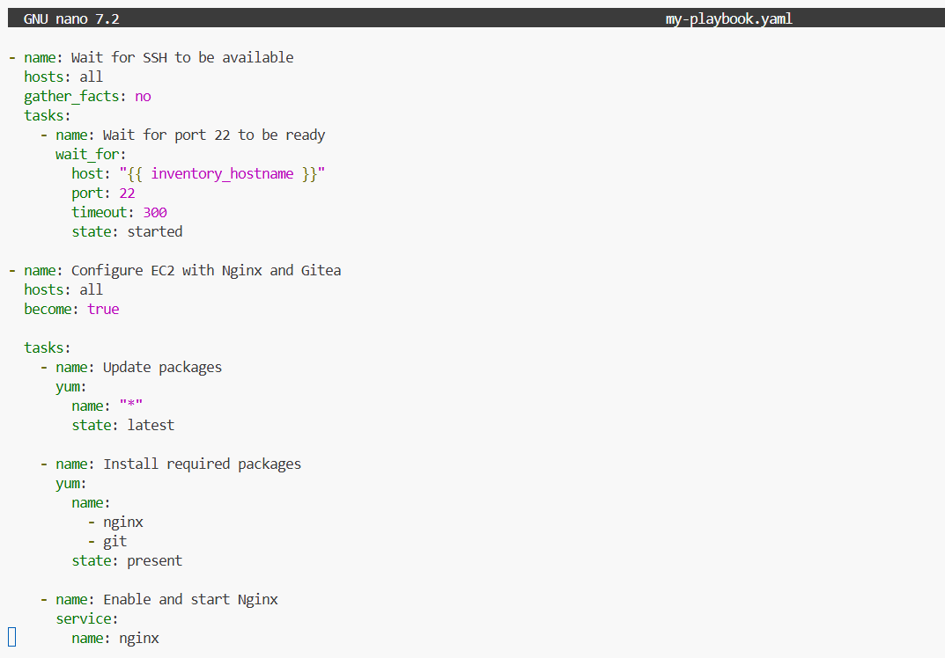
- Destroy and apply again:
task10_terraform_apply_after_wait.png — apply output after wait fix.
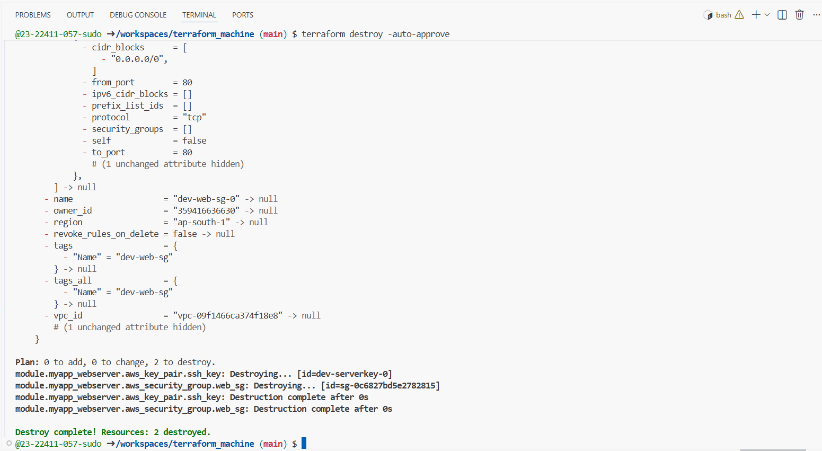
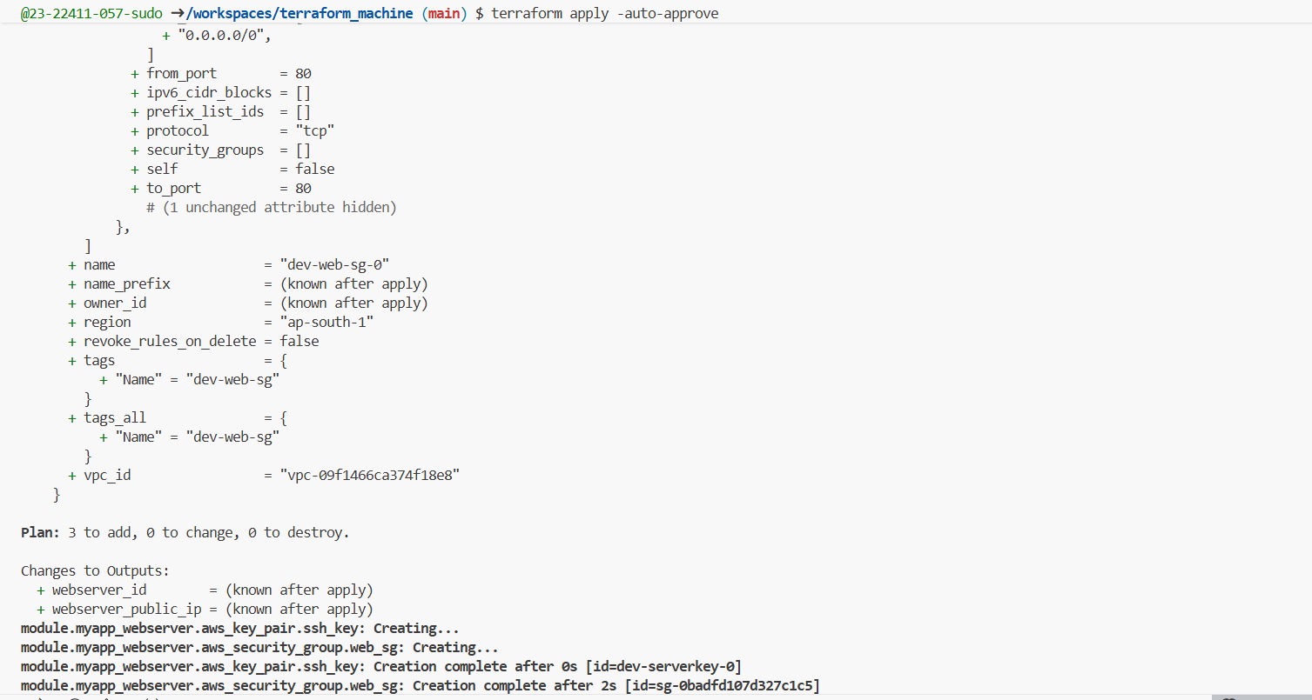
- Verify Gitea / Nginx application is reachable at the appropriate URL.
task10_app_browser_post_null_resource.png — browser confirming app is up after Terraform+Ansible.

Task 11 – Dynamic inventory with aws_ec2 plugin
Let Ansible discover EC2 instances dynamically via the aws_ec2 inventory plugin.
- Update ansible.cfg:
task11_ansible_cfg_aws_ec2.png — content of ansible.cfg with plugin configuration.
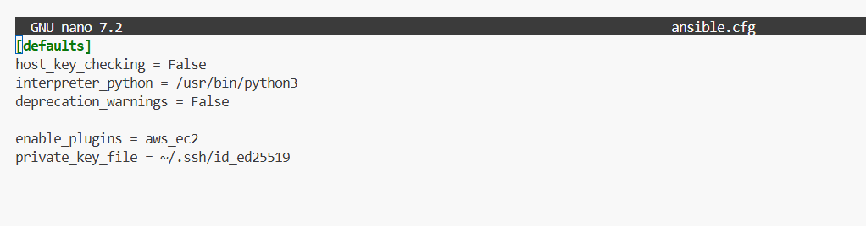
- Create inventory_aws_ec2.yaml:
task11_inventory_aws_ec2_created.png — file created.
task11_inventory_aws_ec2_initial.png — content of initial inventory file.
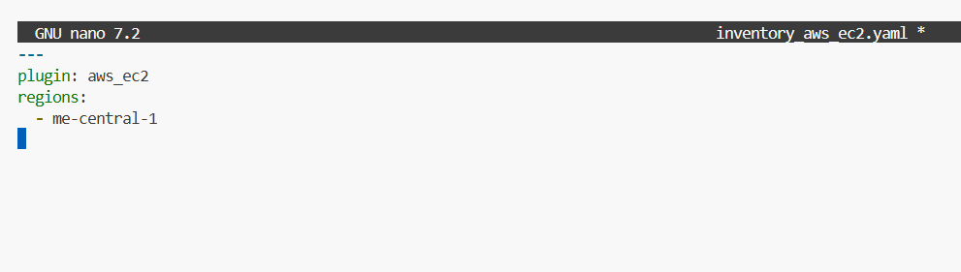
- Ensure Terraform code includes both dev and prod webservers in main.tf:
task11_main_tf_dev_prod_modules.png — snippet of main.tf showing myapp-webserver and myapp-webserver-prod.
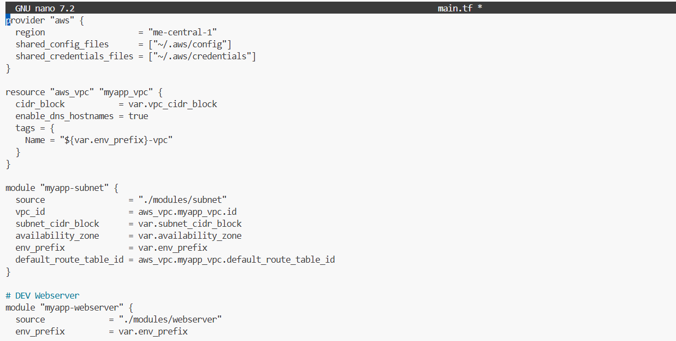
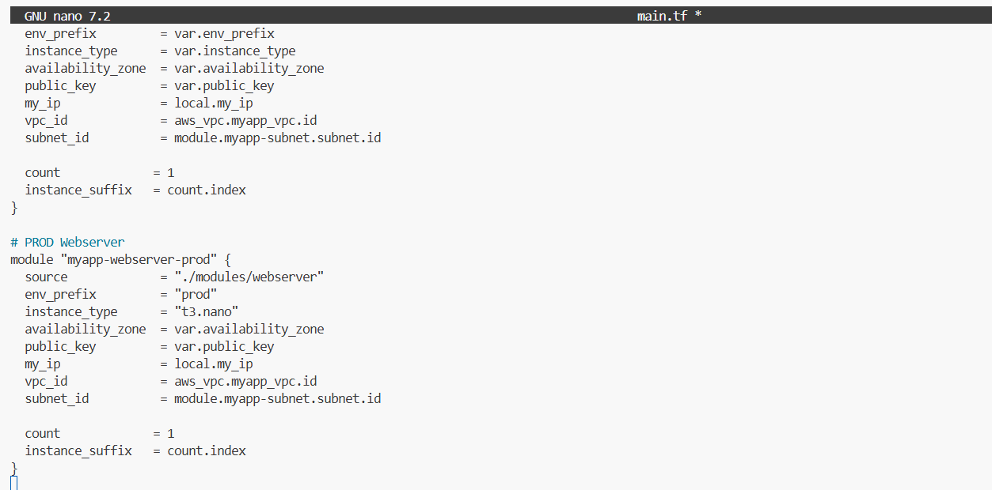
- Add outputs in outputs.tf:
task11_outputs_tf_dev_prod_ips.png — content of outputs.tf with both outputs.
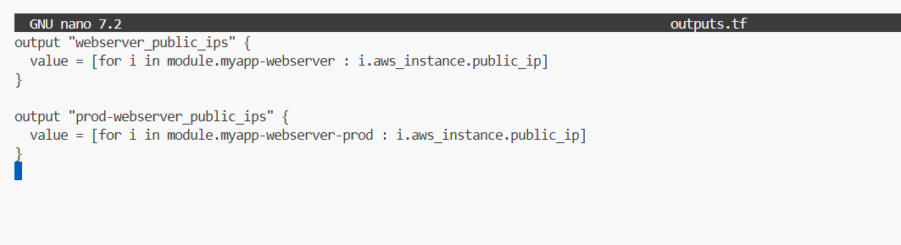
- Rebuild infra:
task11_terraform_apply_dynamic_setup.png — apply output for dev/prod instances.
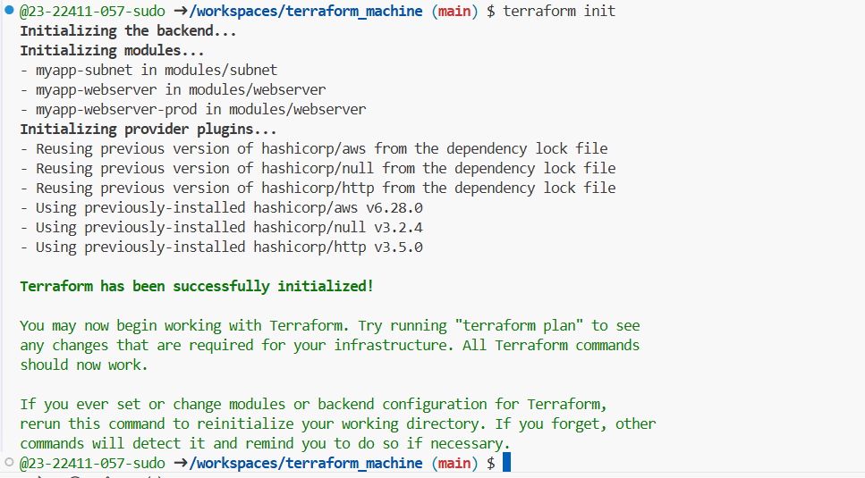
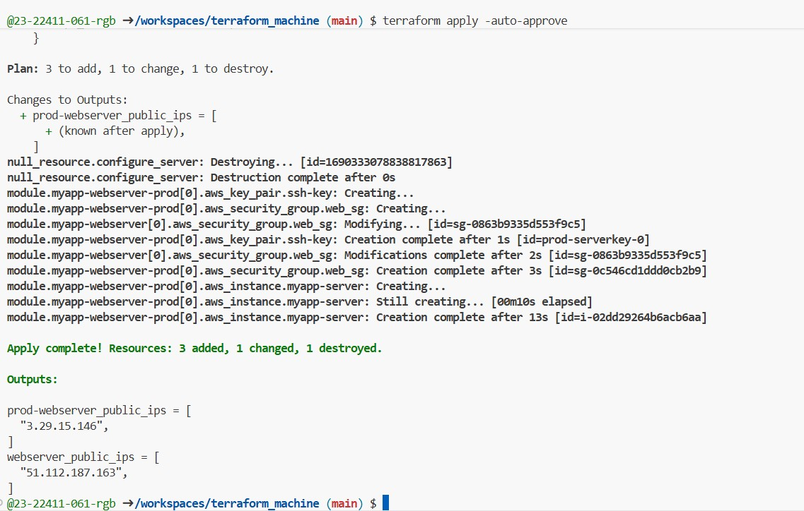
task11_terraform_output_dynamic_ips.png — terraform output showing dev and prod IPs.
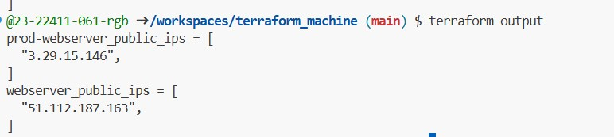
- Install boto3 and botocore:
task11_boto_install.png — pip install output.
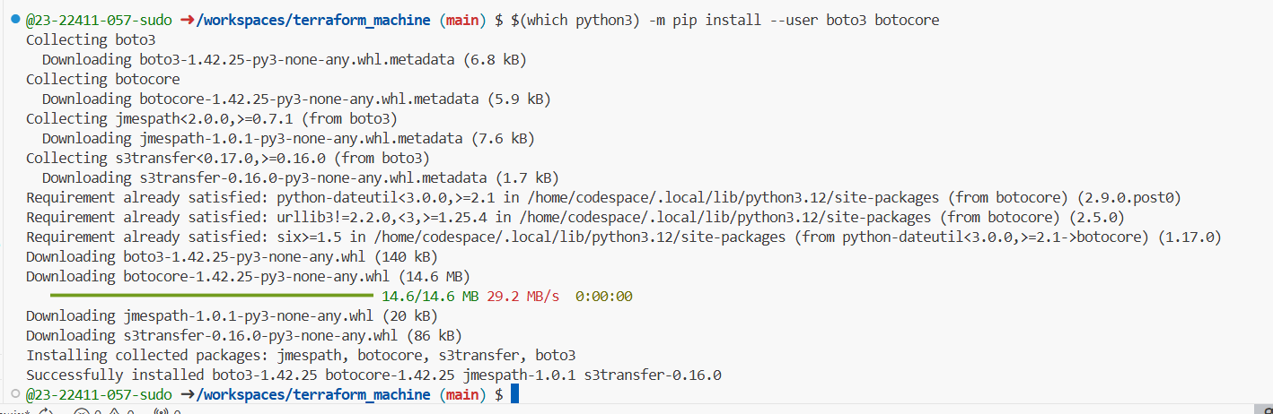
task11_boto_version.png — printed version line.
- Check inventory graph:
task11_ansible_inventory_graph_initial.png — graph output showing @all, @ungrouped, and @aws_ec2 hosts.
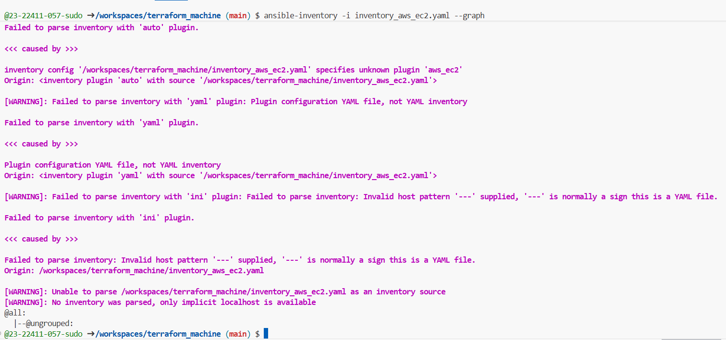
Task 12 – Filtering EC2 instances by tags & instance type
Augment the inventory plugin to group by tags and instance type, then limit plays to specific groups.
- Modify inventory_aws_ec2.yaml to add tag-based grouping:
task12_inventory_aws_ec2_tag_groups.png — updated inventory file.
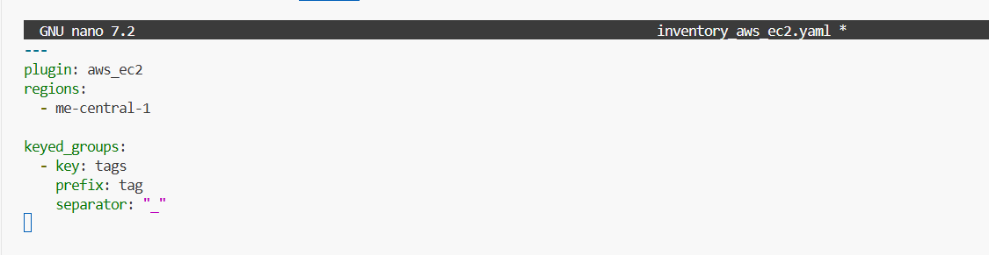
task12_inventory_graph_tag_groups.png — ansible-inventory graph showing tag groups.\
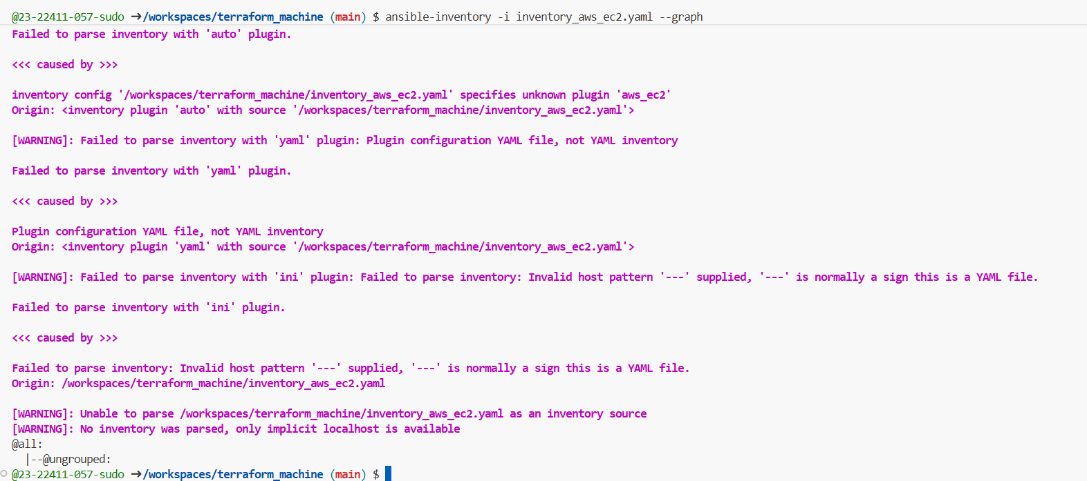
- Extend to group by instance type as well:
task12_inventory_aws_ec2_instance_type_groups.png — inventory with tags + instance_type.
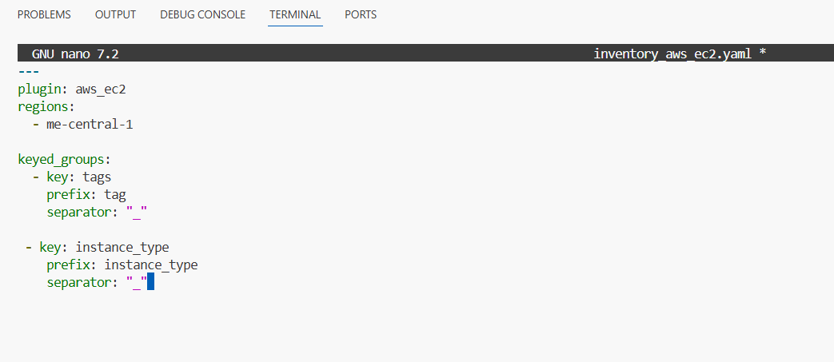
task12_inventory_graph_full.png — graph showing both tag and instance type groups.
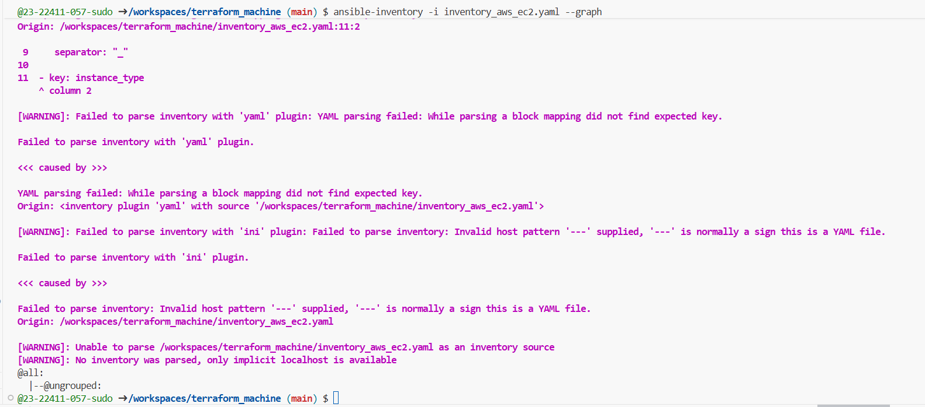
- Prepare my-playbook.yaml for nginx+SSL+PHP on hosts: all:
task12_my_playbook_all_hosts.png — playbook configured for hosts: all.
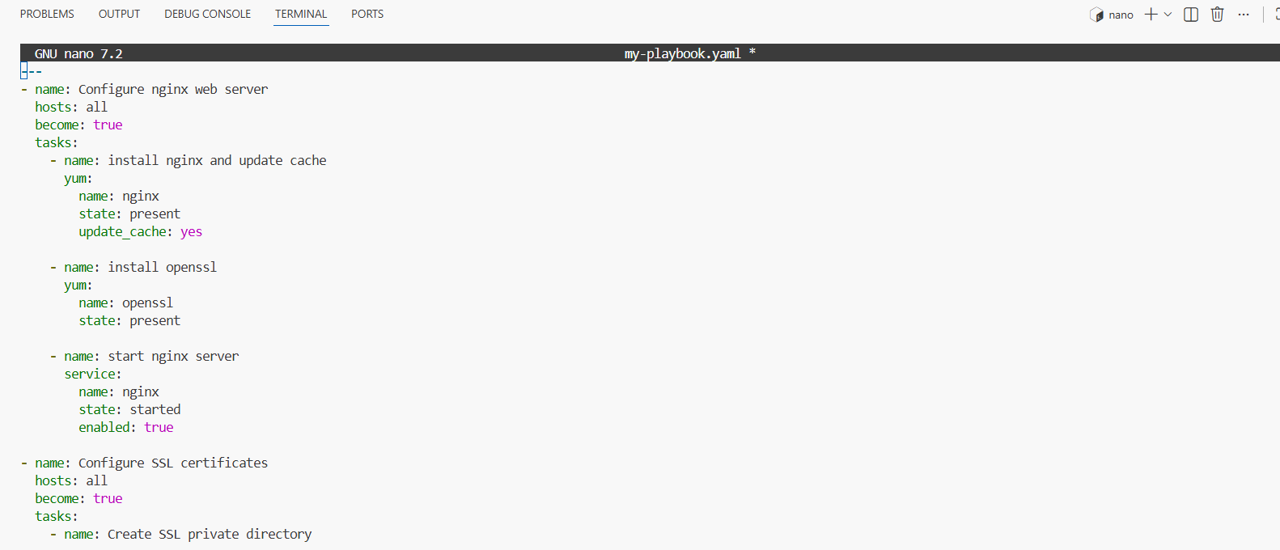
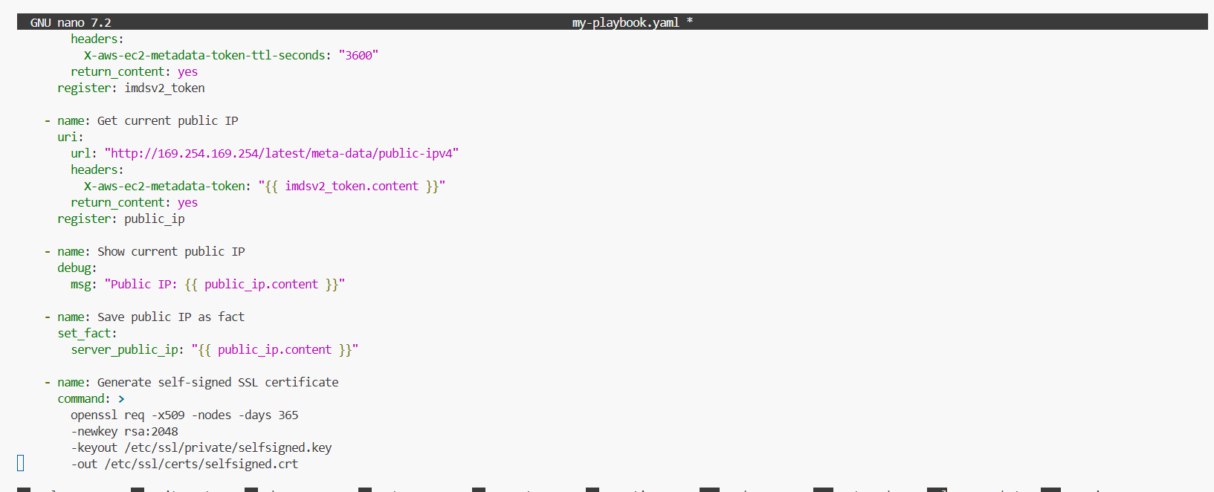
- Run on all instances:
task12_ansible_play_all.png — output showing all dev+prod hosts configured.
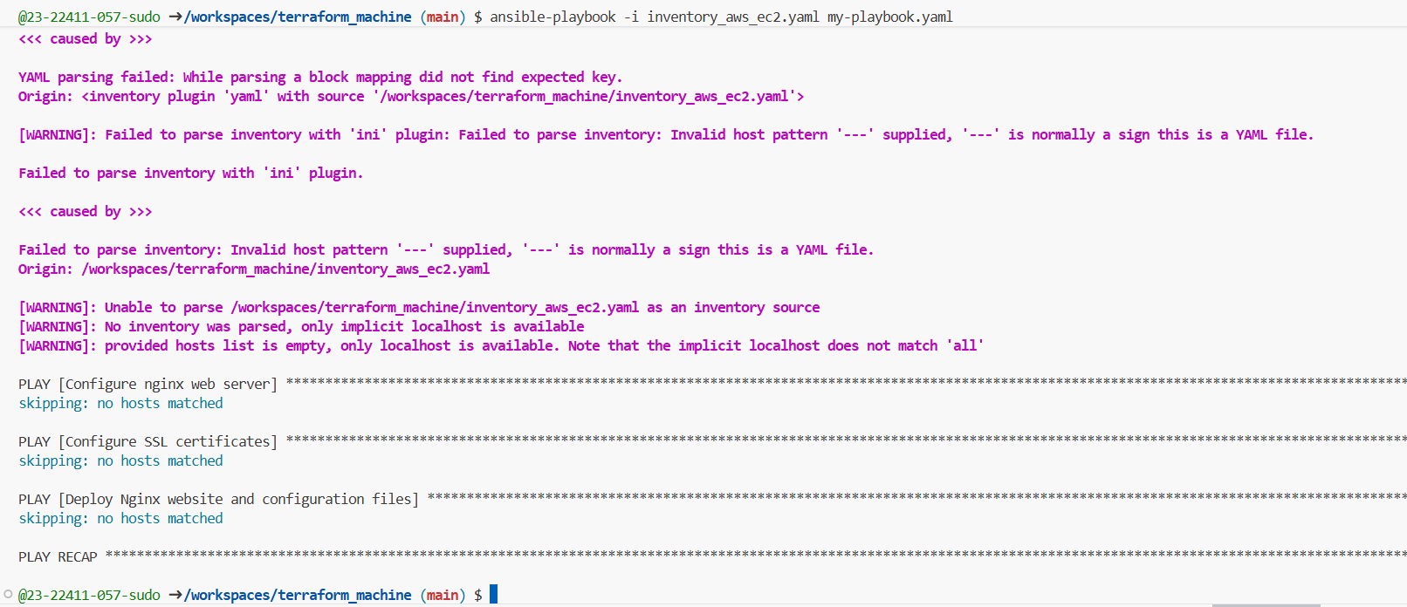
- Run only on dev instances:
task12_ansible_play_dev_only.png — filtered run for dev group.
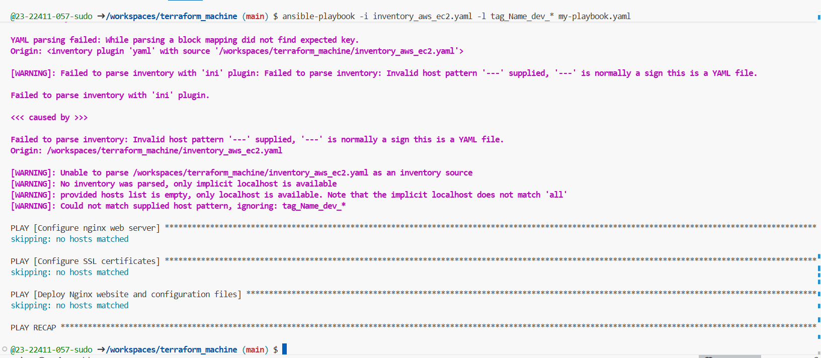
- Run only on prod instances:
task12_ansible_play_prod_only.png — filtered run for prod group.
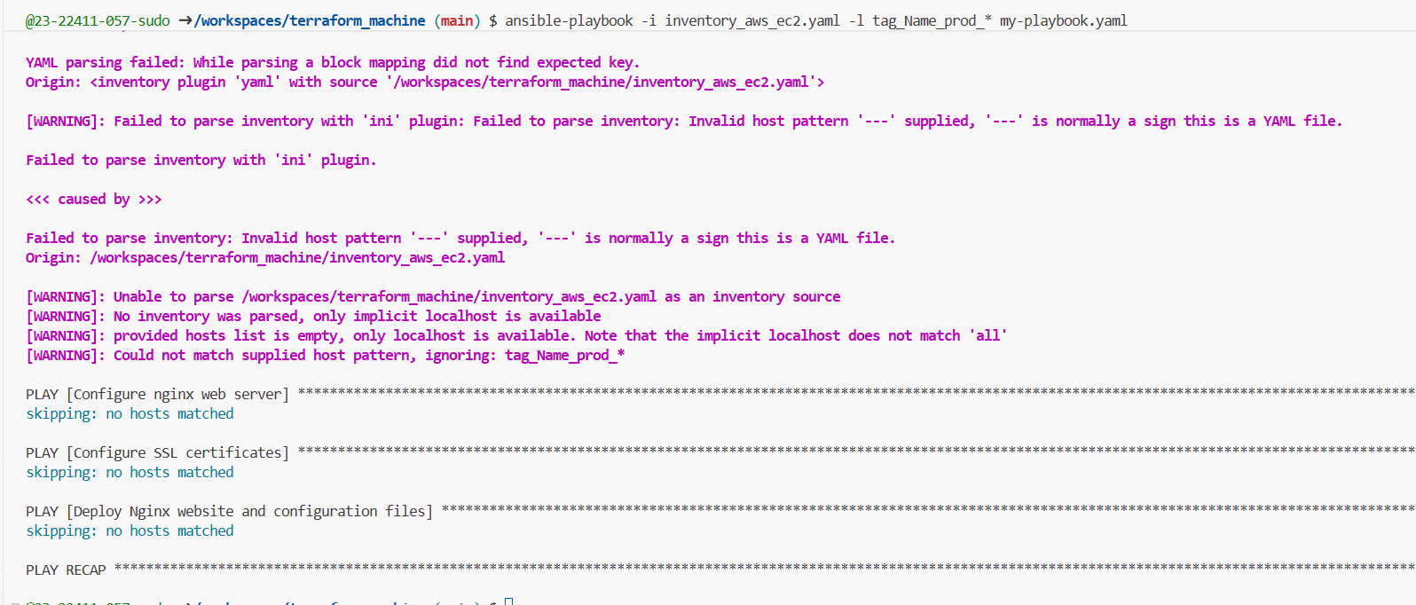
- Run only on t3.micro instances:
task12_ansible_play_t3_micro.png — run for instance_type_t3_micro.
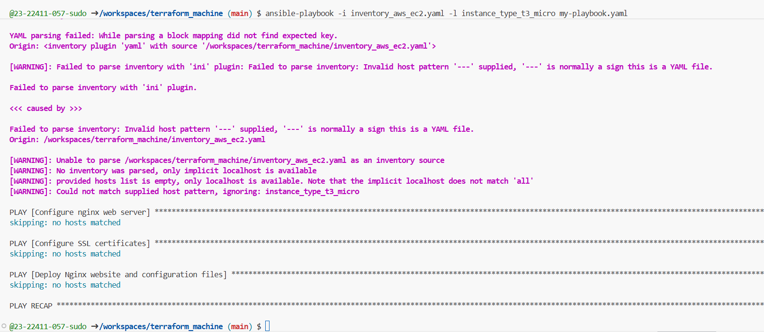
- Run only on t3.nano instances:
task12_ansible_play_t3_nano.png — run for instance_type_t3_nano.
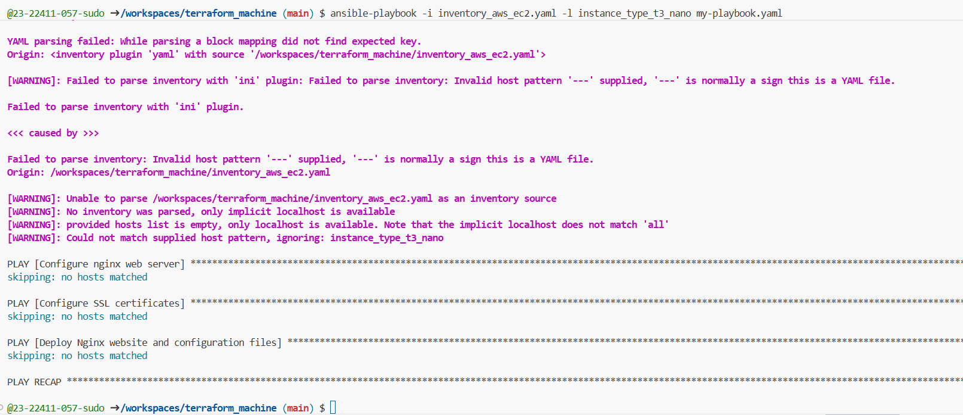
- Update ansible.cfg to use inventory by default:
task12_ansible_cfg_inventory_default.png — ansible.cfg with inventory = ./inventory_aws_ec2.yaml.
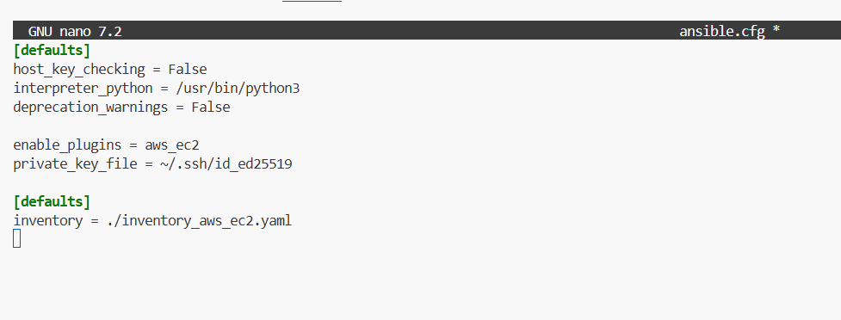
- Now you can simply run:
task12_ansible_play_t3_nano_no_i.png — run using default inventory (no -i).
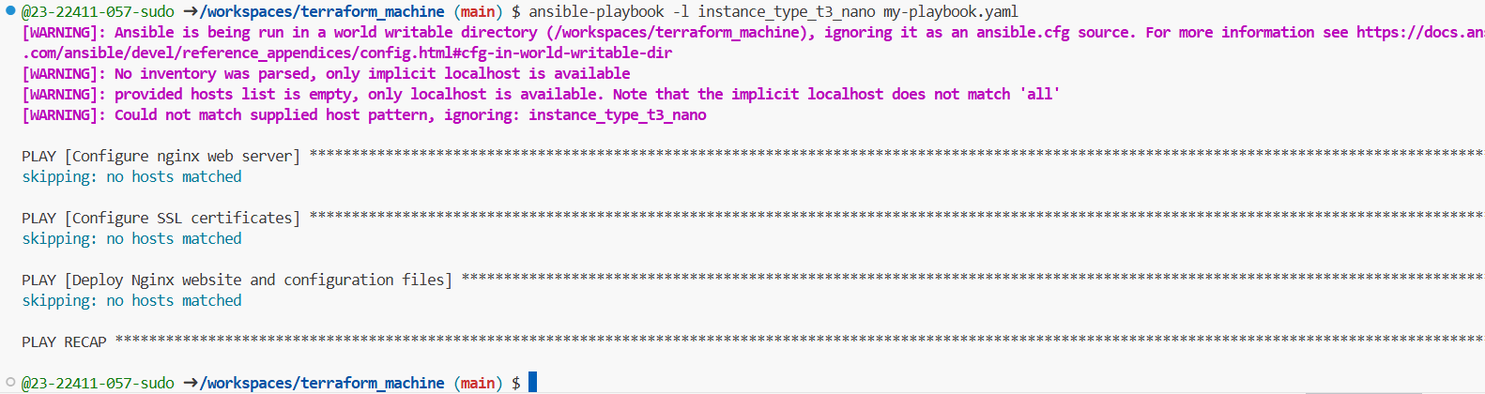
Task 13 – Ansible roles: nginx, ssl, webapp
Reorganize your configuration into roles.
- Update main.tf for a simple dev environment with 1 instance (as shown previously).
task13_main_tf_single_dev.png — main.tf snippet with single myapp-webserver count=1.
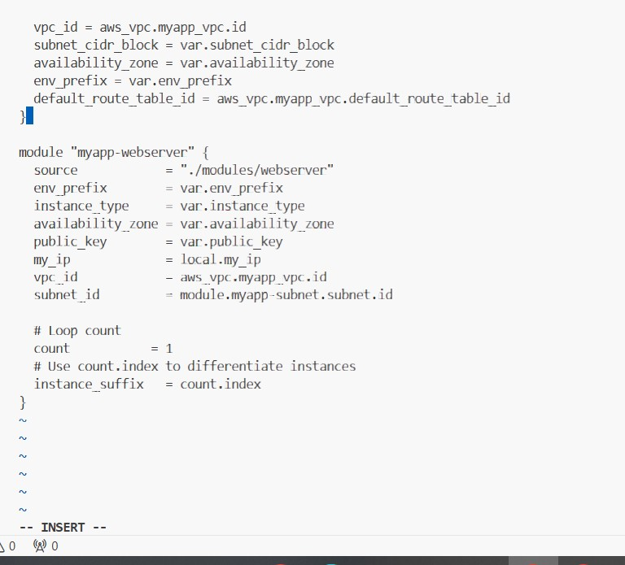
- Create /ansible structure:
task13_ansible_structure_created.png — ls -R showing ansible/, inventory/, roles/, ansible.cfg, my-playbook.yaml.
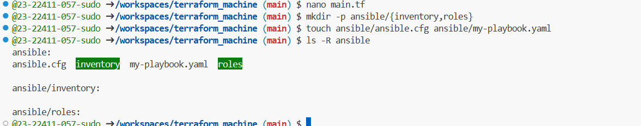
- ansible/ansible.cfg:
task13_ansible_cfg_project.png — content of ansible/ansible.cfg.
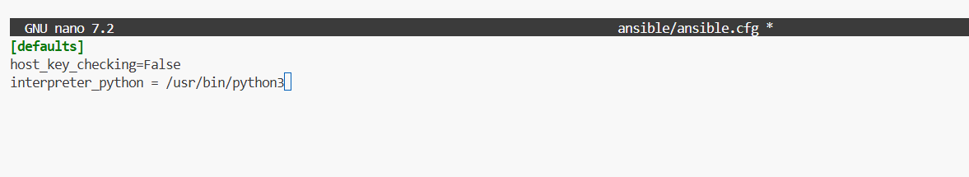
- ansible/inventory/hosts:
task13_ansible_inventory_hosts.png — content of ansible/inventory/hosts.
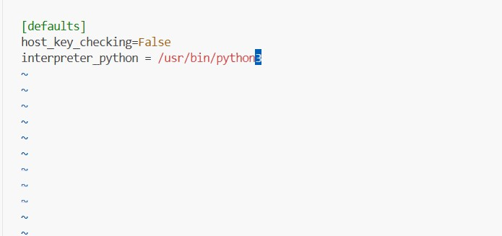
- Create roles:
task13_roles_created.png — ls -R under ansible/roles showing nginx, ssl, webapp.
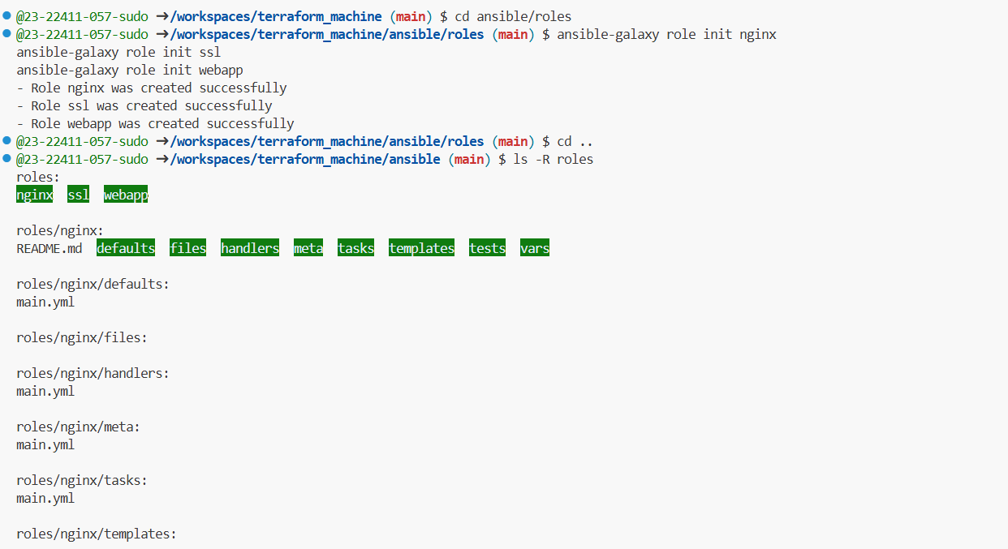
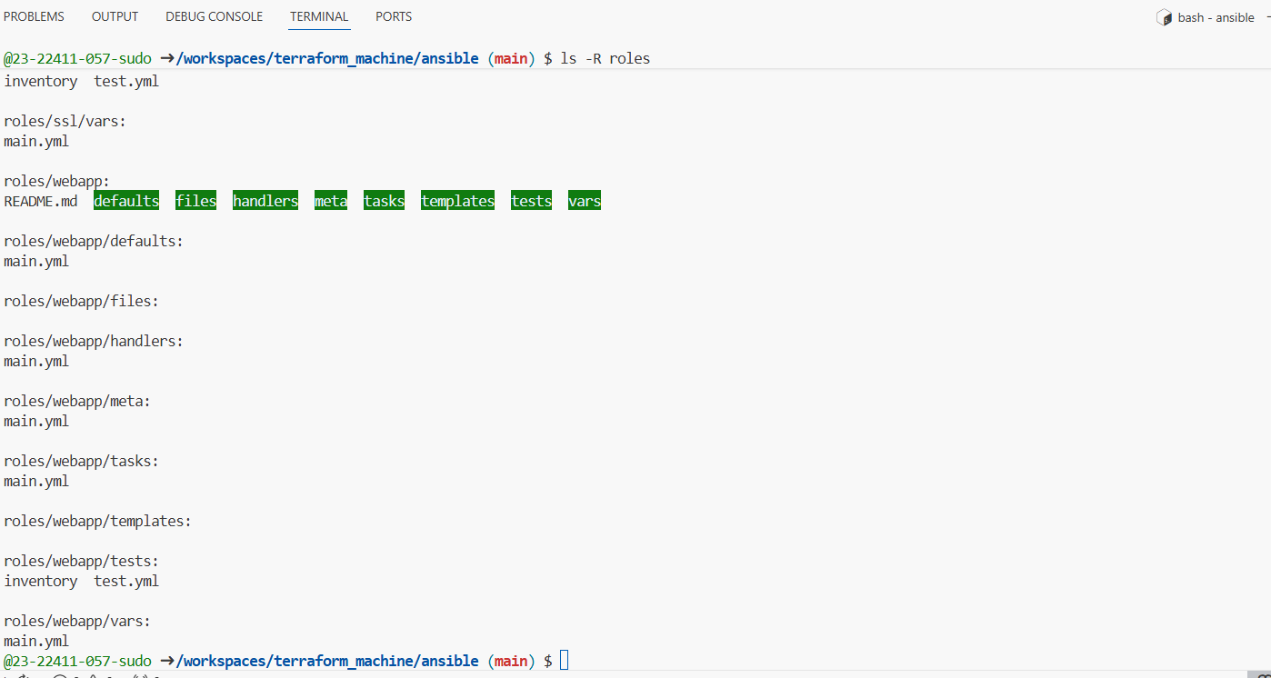
- Role: nginx
task13_nginx_handlers_main.png — content of roles/nginx/handlers/main.yml.
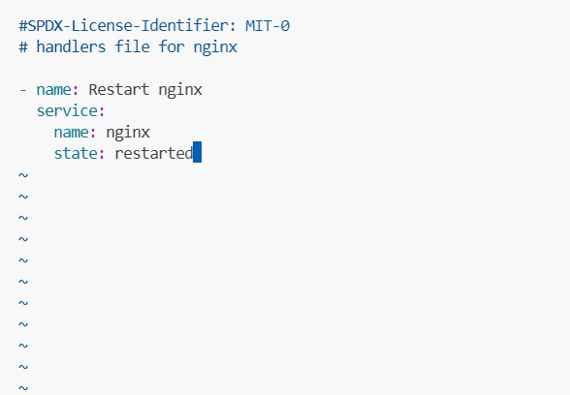
task13_nginx_tasks_main.png — content of roles/nginx/tasks/main.yml.
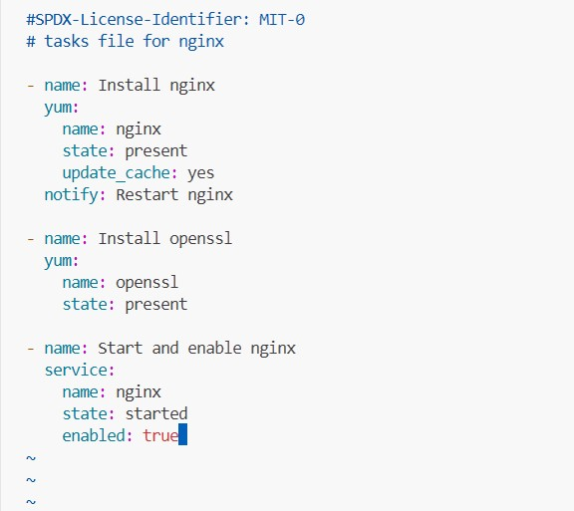
- First role-based playbook ansible/my-playbook.yaml:
task13_my_playbook_nginx_only.png — playbook using only nginx role.
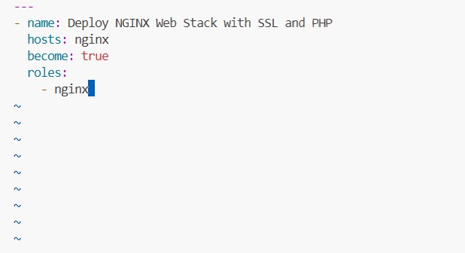
task13_ansible_play_nginx_only.png — playbook output.
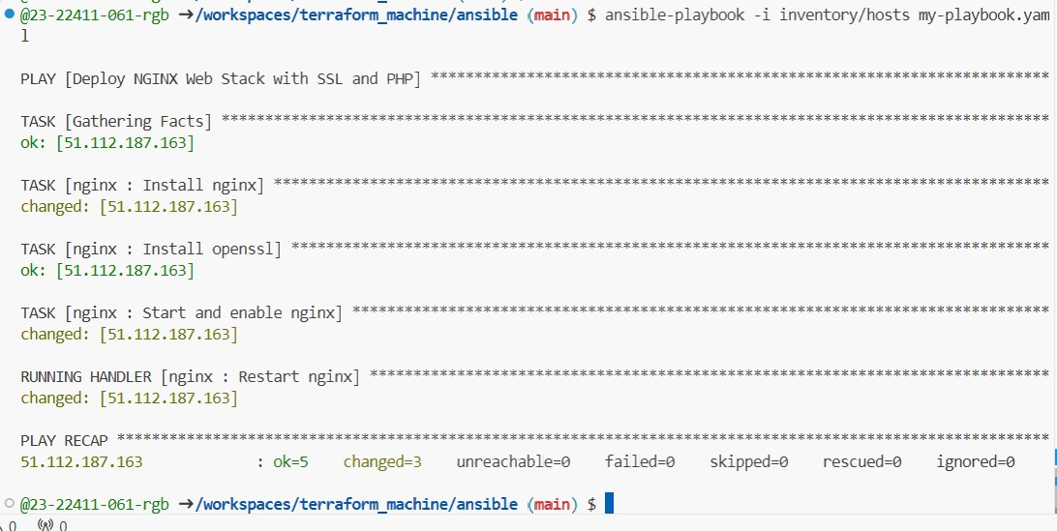
task13_nginx_browser_roles.png — browser showing nginx default page via roles.
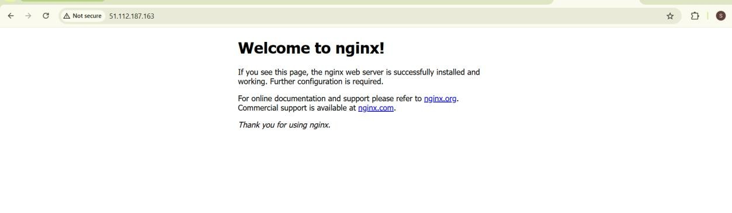
- Role: ssl
task13_ssl_defaults_main.png — content of roles/ssl/defaults/main.yml.
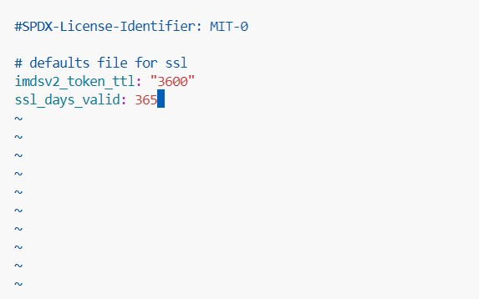
task13_ssl_tasks_main.png — content of roles/ssl/tasks/main.yml.
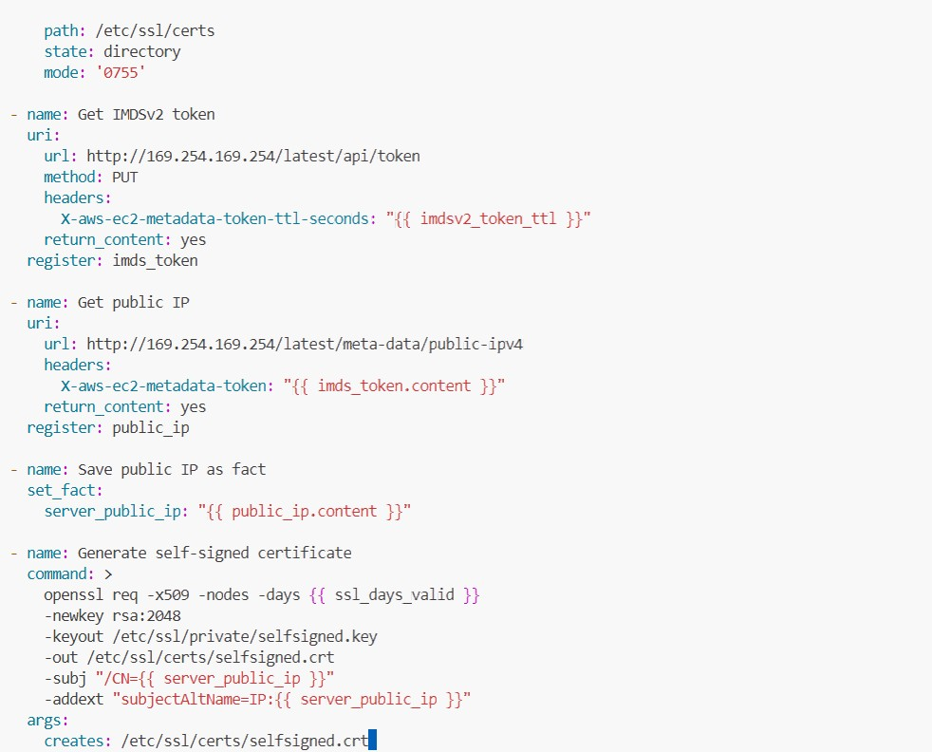
- Role: webapp
task13_webapp_defaults_main.png — content of roles/webapp/defaults/main.yml.
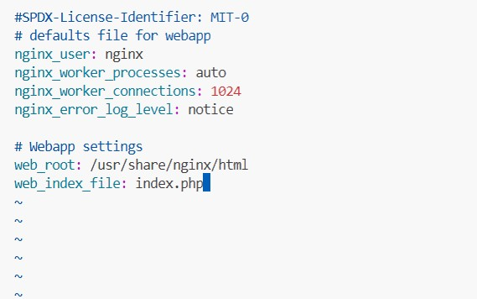
task13_webapp_files_index_php.png — content of roles/webapp/files/index.php.
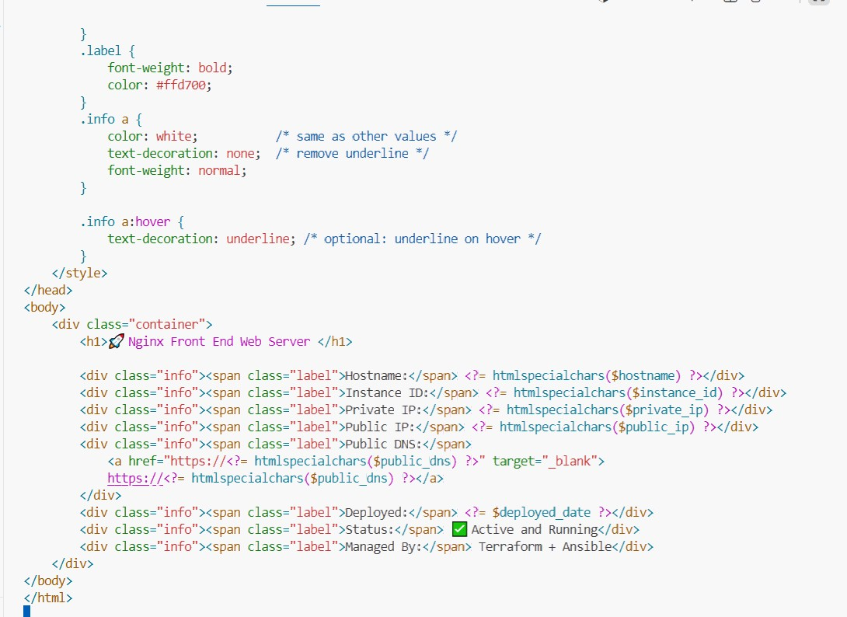
task13_webapp_handlers_main.png — content of roles/webapp/handlers/main.yml.
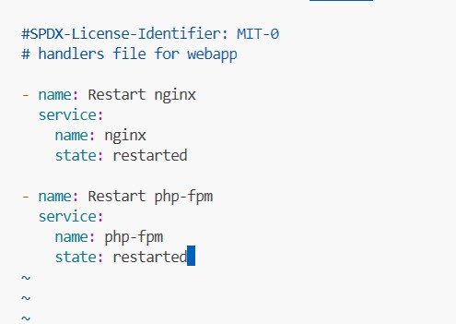
task13_webapp_templates_nginx_conf.png — content of roles/webapp/templates/nginx.conf.j2.
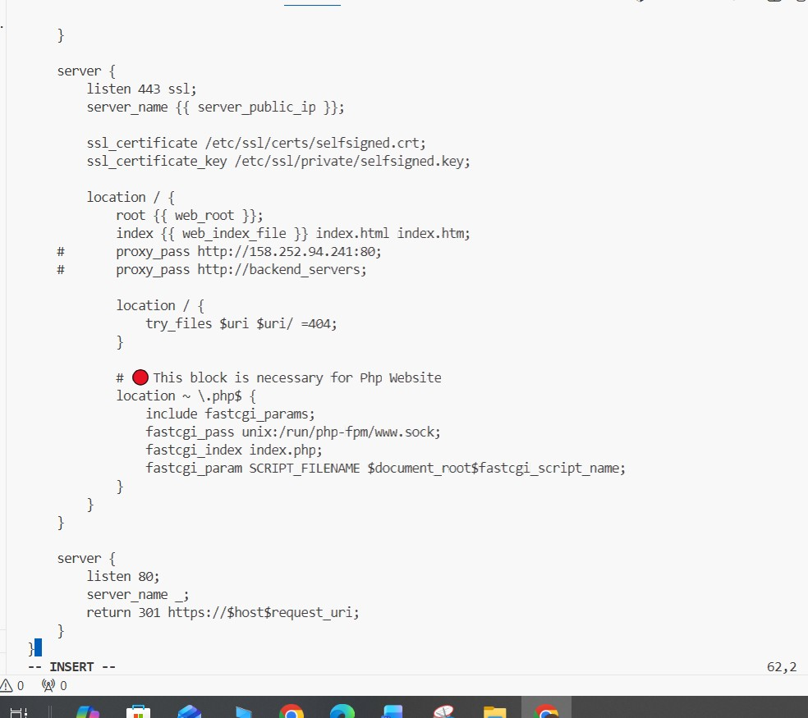
task13_webapp_tasks_main.png — content of roles/webapp/tasks/main.yml.
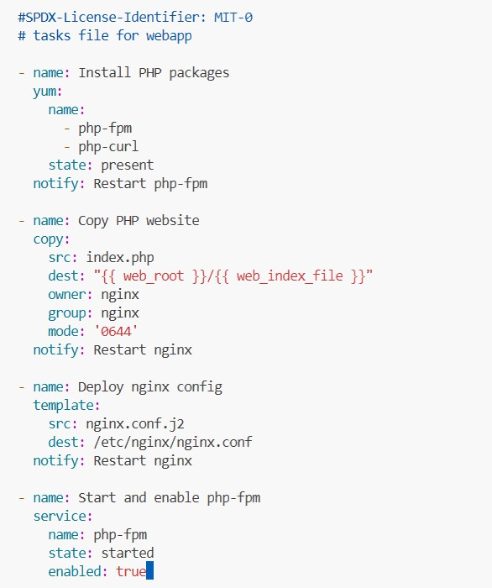
- Final role-based playbook ansible/my-playbook.yaml:
task13_my_playbook_roles.png — final my-playbook.yaml referencing three roles.
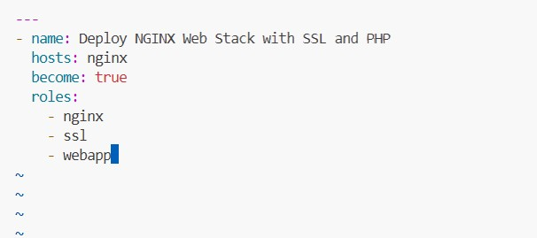
- Run:
task13_ansible_play_roles.png — playbook output with all roles executed.
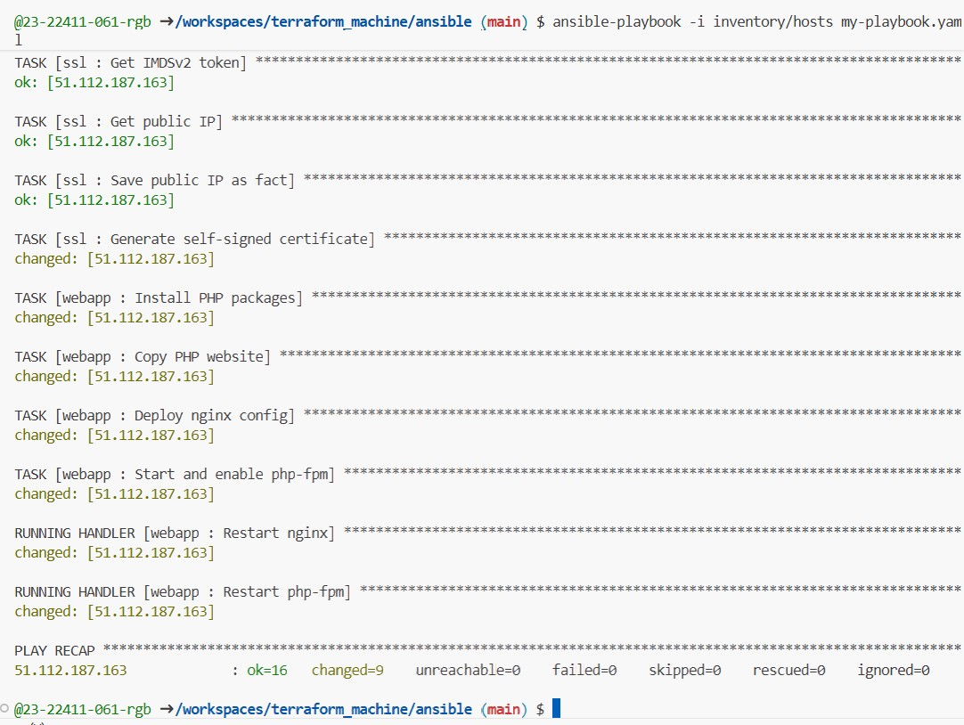
Task13_php_https_browser_roles.png — browser showing final PHP page via HTTPS.
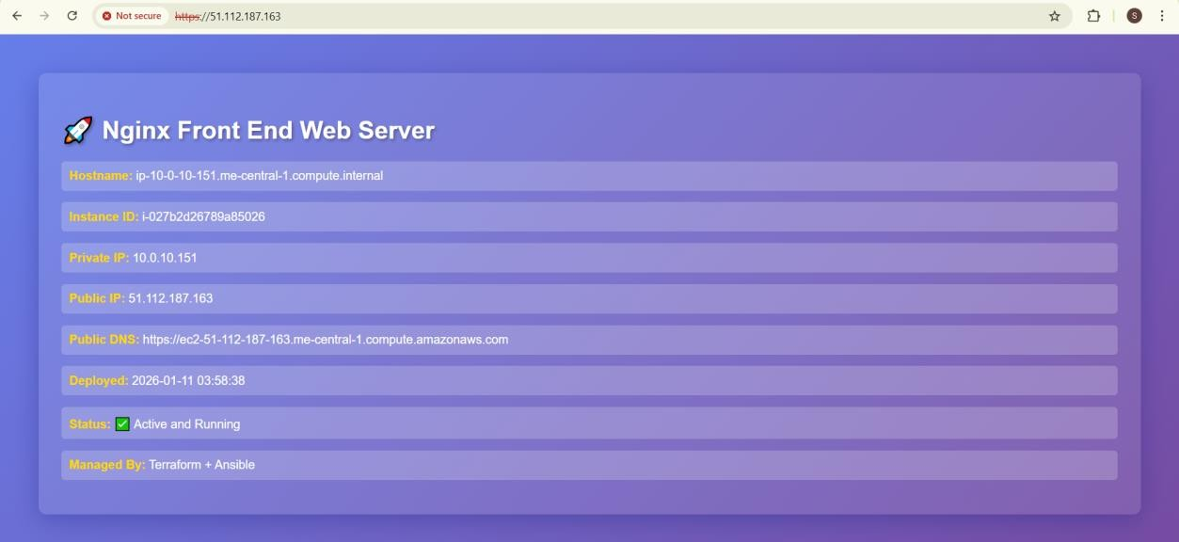
Cleanup
- From the Terraform root:
cleanup_terraform_destroy.png — terminal showing destroy output.

- Verify state:
cleanup_tfstate.png — terraform.tfstate showing no active resources or is empty.
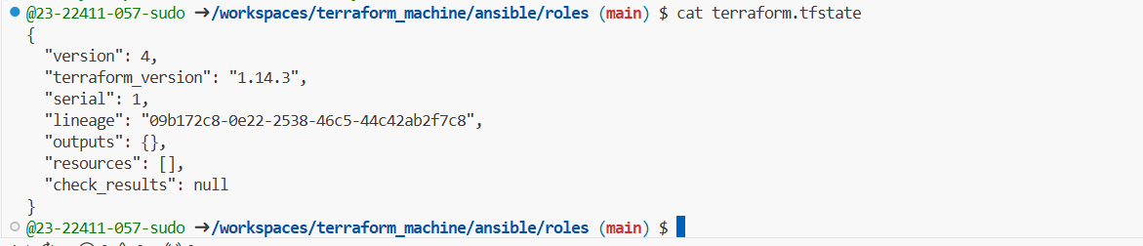
- Confirm that no EC2 instances remain in AWS console.
cleanup_aws_console.png — AWS EC2 console showing zero running instances for this lab.
